2018
Michael E. Cohen Residents Research Day

State University of New York at Buffalo, Department of Neurology Jacob’s School of Medicine and Biomedical Sciences

Friday, June 8, 2017 10:30 am—4:30 pm

Graduating Residents

Sandhya Mehla, MBBS
Adult Neurology, PGY4
(Chief Resident)

Daniela Zambrano, MD

Adult Neurology, PGY4
(Chief Resident)

Muhammad Ahmed, MBBS Adult Neurology, PGY4

Rabia Ghazi, MBBS Adult Neurology, PGY4

David Okonkwo, MD

Harshit Shah, MBBS

Child Neurology, PGY5

Adult Neurology, PGY4

Alok Singla, MBBS

Child Neurology, PGY5

PGY IV Resident 2018-2019
Evelyn Berman, MD

Child Neurology, PGY4

PGY III Residents 2018-2019

Felix Cheng, MD
Adult Neurology, PGY3

Alise Pham, DO
Adult Neurology, PGY3

Kevin Schmitt, MD Evelyn Walsh, MD Adult Neurology, PGY3 Adult Neurology, PGY3

Zilfah Younus, MBBS
Adult Neurology, PGY3

PGY II Resident 2019-2020

Edina Komlodi-Pasztor, MD, PhD

Adult Neurology, PGY2

State University of New York at Buffalo,

Department of Neurology,
Jacob’s School of Medicine and Biomedical Sciences

Welcome/Introduction

10:30 am Gil I. Wolfe, MD, FAAN

Robert Zivadinov, MD, PhD, FAAN Nicholas J. Silvestri, MD

Presentation Session # 1

10:45 am Muhammad Ahmed, MBBS
11:05 am Rabia Ghazi, MBBS
11:25 am Sandhya Mehla, MBBS
11:45 am Harshit Shah, MBBS
12:05 pm Daniela Zambrano, MD
12:25 pm Break/Lunch

Presentation Session # 2

12:55 pm Alok Singla, MBBS

1:15 pm David Okonkwo, MD
1:35 pm Evelyn Berman, MD
1:50 pm Zilfah Younus, MBBS
2:05 pm Evelyn Walsh, MD
2:20 pm Break/Photo Session

Presentation Session # 3

2:40 pm Kevin Schmitt, MD
2:55 pm Alise Pham, DO
3:10 pm Felix Cheng, MD
3:25 pm Edina Komlodi-Pasztor, MD, PhD
3:40 pm End of presentations

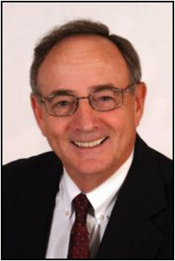
Michael Cohen, MD, Professor of Neurology and Pediatrics, State University of New York at Buffalo; Department of Neurology, Jacob’s School of Medicine and Biomedical Sciences

Research day in the Department of Neurology is always auspicious, for the residents and faculty alike. It is a time to reflect on the years spent at this University and the influence that your peers and the faculty have had on your development as sophisticated physicians.

Today, for the graduating seniors, marks a new beginning, a transition from student to fully-trained neurologic physician. I suspect the journey for many has been marked by joy and stress, doubt and attribution and above all pride, in your accomplishment.

As a faculty, we are delighted at your development and the list of all of your accomplishments. Your group has been recognized as teachers, authors and caring physicians.

As you move on in your life's journey, remember well the gifts given to you by this University. Continue to study and learn, honor your patients and as demonstrated to us, your teachers, "be all you can be".

We will miss you but recognize that we have helped you prepare for the future. Do well and stay in touch!

Michael E. Cohen, MD, FAAN, FANA, is a Professor of Pediatrics and Neu-rology. Dr. Cohen was Chair of the UB Neurology Department from 1983-2000. He is a past President of the Child Neurology Society, The Associa-tion of Child Neurology Professors and past President of the Section of Child Neurology of the American Academy of Neurology. He has been responsible for several of the all-day child neurology courses given at the annual meeting of the academy. He was a member of the organizing committee of the ABPN for neurodevelopmental neurology and has served on the writing committee for recertification for child neurology of the ABPN. His research interests have been primarily in neuro-oncology.

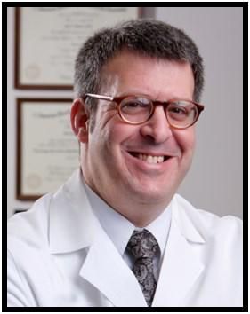
Gil I. Wolfe, MD, FAAN Chair, Department of Neurology University at Buffalo; Jacob’s School of Medicine and Bio-medical Sciences.

Welcome to the Michael E. Cohen, M.D., Resident Research Day; the annual event held by the University at Buffalo’s Department of Neurol-ogy staged in recognition of research projects conducted by our resi-dents and fellows. This year’s event is of special note given Dr. Co-hen’s semi-retirement. He will continue to teach on behalf of our de-partment and medical school.

Our research day represents the culmination of months and even years of meticulous work by our neurology trainees. This work is now subjected to peer scrutiny and competition for awards.

Moreover, the research day recognizes the involvement of our faculty and fellows in the mentorship of residents. Experience and lessons learned are passed from each generation of physician researchers to the next in just this way.

Through the years, graduates of our program have repeatedly con-firmed the invaluable experience of their participation in the Research Day. Their comments express an increased appreciation not only for the clinical research process itself but also for the positive impact it will always have on their clinical careers.

Today's presentations continue an established tradition of academic excellence. Please join the entire UB Department of Neurology in commending each resident and fellow for the innovation, scope and execution of their projects. On display are analytical skills, judgment and integrity. Please also accept my sincere appreciation to all of you for contributing to and sharing the day's events.

Best,
Dr. Wolfe

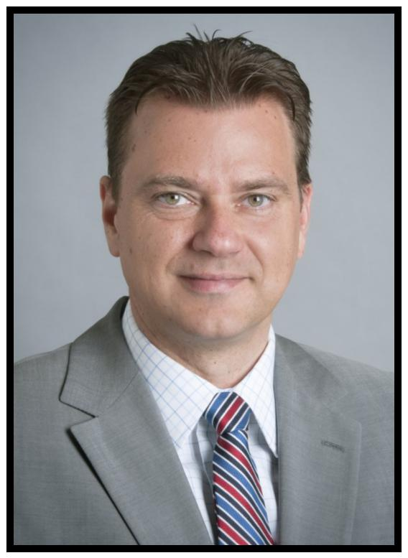
Robert Zivadinov, MD, PhD, FAAN,
FANA, FEAN
Resident Research Training

Program Director
Professor of Neurology,
State University of New York at
Buffalo; Department of Neurology
Jacob’s School of Medicine and
Biomedical Sciences

BNAC Director
MR Director of Imaging, CTRC

Thank you for joining us for the fourteenth annual Residents Re-search Day, and congratulations to our participants. Once again, these fine residents offer a wide scope of projects to be presented today, displaying knowledge, resourcefulness, deter-mination, and commitment to their field.

Whether our presenters’ careers lead towards clinical work or fur-ther research, they are true scholars, having exhibited the dis-cernment, intuition and drive that will guide them in future years. I congratulate each and every one of them for a job superbly done.

It has been my primary purpose these last few years to foster and facilitate an expansion of project diversity. As you see in your program today, although we continue to foster study in the areas of our strength and mainstays – stroke and multiple sclerosis – we continue to increase the number of projects that explore other neurological disorders and diseases.

With these additional advancements, we hope to “pave the way” to new levels of research distinction. Projects that are pro-gressively far-reaching and innovative will considerably advance the careers of our new physicians as well as enhance both the importance and notoriety of our Neurology Residency Program. What a wonderful endeavor to be part of!

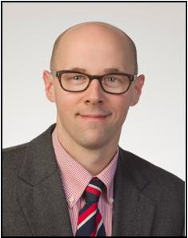
Nicholas J. Silvestri, MD, Associate Professor of Clinical Neurology Program Director, Adult Neurology Residency, State University of New York at Jacob’s School of Medicine and Biomedical Sciences

It gives me great pleasure to see yet another class of resi-dents graduate from our training program. Over the past three years, we have watched these individuals grow into outstanding clinicians, teachers, and scientists. I am cer-tain that they will continue to make us proud.

As the end of another academic year approaches, I am inspired by the enthusiasm and fortitude of our trainees. I would like to thank all of our residents for their hard work and dedication. I would also like to thank the faculty for their devotion to teaching and their support of the training program.

Finally, I would like to acknowledge the outstanding efforts of Ms. Eva Tamoga and Mr. Tom Bellanca who work tireless-ly in support of the program.

A native of Western New York, Dr. Silvestri has been on faculty in the De-partment of Neurology since 2009 and Program Director of the Adult Neurology Residency since 2011.

Assessing the Relationship Between Tonsillec-tomy and Infectious Mononucleosis and their Association to MS Risk and Disease Activity

Muhammad Khaleeq Ahmed, MBBS
Bianca Weinstock-Guttman, MD
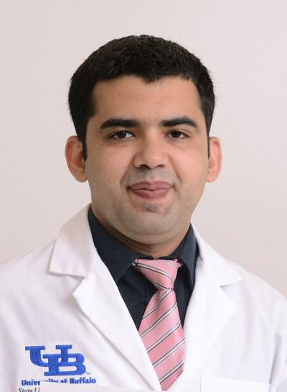

Khaleeq is a PGY-4 resident at the UB Neurology residency program. He grew up in Bahawalpur, a relatively small town Pakistan, but rich in educational and cultural heritage. He completed his medical school from his home town at QAMC in 2010. After completing a rotating internship, he worked at a small medical center serving underserved communities, which inspired him to pur-sue advanced training.

His journey away from his home country started with his work in highly ad-vanced neuroimaging lab at Thomas Jefferson University, Philadelphia, under Dr. Joseph Tracy, where his work involved studying role of fMRI and DTI in evaluating language function with temporal lobe epilepsy. Later on he worked with Dr. Ching and Dr. Sawyer, as a research associate, stroke research divi-sion at Gates Vascular institute, where he was involved in different projects that include stroke outcome measures.

He enjoys reading, especially history, movies and spending time with family. His research interests include cerebrovascular disease and demyelinating dis-orders. Dr. Ahmed is excited to continue as vascular neurology fellow at Uni-versity of Texas at Houston.

Background:

Multiple sclerosis is an immune mediated demyelinating disease with involvement of lymphoid tissue, in terms of activation of T-cells and B cell, and lymphoid tissue especially tonsils including palatine and adenoid, are involved in activation of T-cell along with regulatory B Cells, which is involved in pathogenesis of MS.

Objective:

To assess the relationship between tonsillectomy and IM history in a cohort of MS patients versus healthy controls (HC) and evaluate the relationship between the disease severity and disease activity (relapsing vs progressive) between MS pa-tients with tonsillectomy versus patients without prior history of tonsillectomy.

Method:

This is cohort-control retrospective review of MS (n=779) and MS center in year 2012 and HC (n=221) were included. Diagnosis of MS, Gender, Age at onset of MS, disease subtype( RRMS=583,SPM=196), history of tonsillectomy (n=470), age of tonsillectomy (mean age=10), family history and EDSS (Expanded Disability Sta-tus Scale), in 2012, duration of disease, EDSS in 2017, change in EDSS, progression into severe disease (SPM), history of Infectious Mononucleosis (IM) and age of IM was compared in two groups of MS patients and HC, and sub-group with history of tonsillectomy vs without tonsillectomy, after adjusting for disease duration year using independent t-test, Fischer exact test and Chi-square test.

Results

Tonsillectomy is associated with severe disease as mean EDSS (4.027 vs 3.443 p=0.022) differ significantly in MS patients with history of tonsillectomy compared to group without. MS patients tend to have history of tonsillectomy more as com-pared to normal healthy individuals (MS patients =39.54 % vs HC 30.1 % OR 1.413 p= 0.0327). MS is correlated to late age of tonsillectomy procedure (mean age MS vs HC= 10.158 vs 8.6 p=0.050). No statistically significant difference for age of onset of MS, disease subtypes disease progression, and history of IM was found in two groups

Conclusions

History of tonsillectomy in MS patients leads to severe disease. Previous studies had contradictory reports on effects of tonsillectomy on autoimmune disease particularly in MS.

Disclosures/Conflicts of Interest: Author has nothing to disclose, see P.36 for disclosures for Dr. Weinstock-Guttman

IRB approval # 00002491

Seizures in Ischemic Stroke Patients Who Receive

Acute Reperfusion Therapy: Incidence, Predictive Factors, Efficacy of Treatment & Outcome

Rabia Ghazi, MBBS

Robert Sawyer Jr., MD

University at Buffalo, Department of Neurology
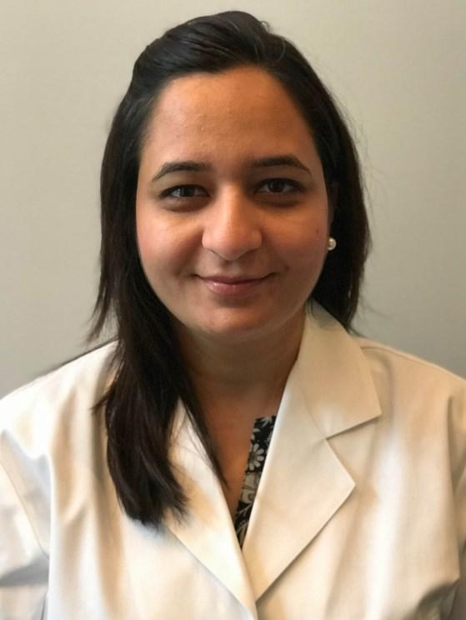

I was born and raised in Lahore (Pakistan) and completed my medical education at one of the most prestigious medical insti-tutes of the country, the King Edward Medical University. After coming to the United States in 2010, I was fortunate to work in MS research with Dr. Guttman, whose commitment and passion for neurology inspired me to pursue a career in Neurology. It was a tough road, but the support of my family and colleagues helped me manage family and work life without compromising one or the other. I love spending time with my twins at home and my future plan is to do a fellowship in movement disorder and/or epilepsy.

Objective:
To study the incidence of early vs late onset seizures, predictive factors, functional outcome, EEG findings and effectiveness of anticonvulsant therapy in ischemic stroke patients who received acute reperfusion therapy.

Introduction:
Previous limited data failed to show an increase risk of seizures in post ischemic stroke patients treated with IV tPA. Results of a multicenter cohort study present-ed recently in American Epilepsy Society Annual Meeting showed increase inci-dence of seizures in ischemic stroke patients who receive acute reperfusion thera-py (tPA or tPA plus mechanical thrombectomy). In this study we evaluated the incidence, influencing factors, EEG findings and effective treatment of seizures and outcome in the patient population who have received IV tPA and or mechanical thrombectomy in our comprehensive stroke center from the beginning of January 2011 till August 2015.

Methods:
This is a retrospectively study of ischemic stroke patients who received acute reperfusion therapy from January 2011 to March 2015 obtained from the Kaleida Health New York State GET WITH THE GUIDELINES database. Following infor-mation is collected for each of these patients: Demographic data, duration be-tween symptom onset to IV tPA and/or mechanical thrombectomy, home medica-tions with focus on anti-convulsant medications, anti- platelets and statins, head CT result prior to, and after IV tPA and/or mechanical thrombectomy, brain MRI findings during admission, location of the infarcts, vessel territory involved, NIH Stroke Scale (NIHSS) on admission, incidence and recurrence of seizures, EEG find-ings, NIHSS at discharge and mRS at discharge as well as seizures occurrence and use of anti-convulsant therapy within the next two years.

Results:
Data was collected for 464 individuals, 6 (1.3%; n=464) during early phase and 23 (10.18%; n=226) experienced seizures. Mechanical thrombectomy was performed for 2 patients (33.3%) who develop early-onset seizures. There was no statistically significant difference in frequency of seizure between those who had tPA with or without mechanical thrombectomy (p-value = 0.64). EEG performed in 38 patients with seizures or suspected seizures showed no evidence of electrographic seizures but other findings (3 were normal, 19 showed generalized slowing, 4 showed right hemispheric slowing, 5 showed left hemispheric slowing and 7 showed sharp waves). Levetiracetam was used as first line anti-convulsant therapy in all patients who develop seizures during the early phase and was effective in controlling sei-zures in 5 out of 6 patients (83.3%). For patients who developed seizures (n=6) the mortality was 33% (mRS of 6 for 2 patients out of 6 who develop seizures in the early phase) whereas the mortality was 13.2% for patients who did not develop seizures in early phase (mRS of 6 for 54 patients out of 440 who did not develop seizures in the early phase).

Conclusion:
The incidence of late onset seizures was significantly higher than early onset sei-zures in ischemic stroke patients. There was no statistical difference in frequency of seizures between the patients who receive tPA alone vs tPA plus mechanical thrombectomy. Among the EEGs performed for patients who developed seizures in our study the most common finding was generalized slowing. Levetiracetam was the most commonly used anti-convulsant drug among our patients who devel-oped seizures and was found to be effective in preventing recurrent seizures in the early phase.

Disclosures: There are no disclosures and no conflicts of Interest.

IRB Approval: #00002368

Sensitivity of Cardiac CTA in Detecting Embolic

Source in Acute Ischemic Stroke Patients

Sandhya Mehla, MBBS
Amit Kandel, MD, MBA

University at Buffalo, Department of Neurology Jacobs School of Medicine and Biomedical Science

Sandhya was born and raised in Kurukshetra, India. She obtained her Medical degree from M. P Shah Government Medical College, Jamnagar, Gujarat, India in 2010. Sandhya has worked in India as a Medical Officer under National Rural Health Mission and as a Junior Resident in Neurology department at an Academic Multispecialty Hospital. She then moved to The United States and joined the Stroke Research department here at UB. She was appointed as a research assis-tant and worked on various ongoing clinical trials and new research projects in-cluding the resident research projects in previous years. She joined UB Neurology Residency program in 2015 after completing her internship at UB Internal Medi-cine Program. Sandhya has also served as co-chief resident this year

Her research interest is in Vascular Neurology and Quality improvement. She has presented her resident research project as a poster at the International Stroke Conference 2017. She has co-authored 4 publications and multiple abstracts pre-sented at various national and international conferences. She also chairs the UB GME Quality Improvement and Safety council which is run by the residents and fellows.

Sandhya wants to pursue her career in Vascular Neurology and Headache Medi-cine, and will move to the University of Massachusetts for her vascular neurology fellowship, followed by a headache medicine fellowship at University of Connecti-cut.

Introduction:

Cardioembolic stroke is one of the most common type of stroke and majority of cryptogenic stroke also turn out to be cardioembolic stroke after extensive evaluation and follow up. This study aims to assess the usefulness of Cardiac/ coronary Computed Tomography Angiogram (CTAC) in the work up for Acute Ischemic Stroke (AIS) patients.

Methods:

A retrospective chart review was conducted on patients who underwent CTAC or Transesophageal Echocardiogram (TEE) for AIS work up from January 2011 to May 2018. Patient demographics, stroke location, severity, risk factors and indications for CTAC were recorded. Reports from all the CTAC and TEE were compared with their transthoracic echocardiogram (TTE) findings. A descrip-tive analysis is performed.

Results:

A total of 30 patient records reviewed in CTAC arm and 33 patients records in TEE arm. In CTAC arm: 2/30 patients had left atrium (LA)/ left ventricular (LV) thrombus which were not evident on TTE, 4/30 showed septal or apical aneu-rysm of which only 2 were suspected on TTE, 5/30 showed significant coro-nary artery atherosclerotic disease. In TEE arm: 2/33 had LA thrombus, 1/33 had interatrial septal aneurysm, 4/33 had significant atherosclerotic disease or atheroma in aortic arch, 6/33 had PFO or shunt of which only 3 had PFO in TTE, 6/33 had dilated LA which was not recorded on TTE. Average duration from initial consult to CTAC was 3.27 days and for TEE was 3.33 days.

Conclusion:

CTAC is much easier and less risk procedure for patients with AIS. CTAC ap-pears to be equally sensitive to TEE in detecting LA and LV thrombus and sep-tal/apical aneurysms but is not helpful to detect cardiac or pulmonary shunt. CTAC provides extra information about the coronary arteries and can be a very cost effective and patient friendly alternative to TEE in carefully selected patients.

IRB approval # STUDY00002435

Conflicts of Interest: Authors have no conflicts of interest to declare.

Disclosures: Authors have no disclosures relevant to the study.

Effect of Statins on Intracerebral Hemorrhage and Outcome After IV Thrombolysis for Acute Ischemic Stroke

Harshit Shah, MBBS Ashkan Mowla, MD, FAHA, FAAN Dr. Robert Sawyer, MD

University at Buffalo, Department of Neurology
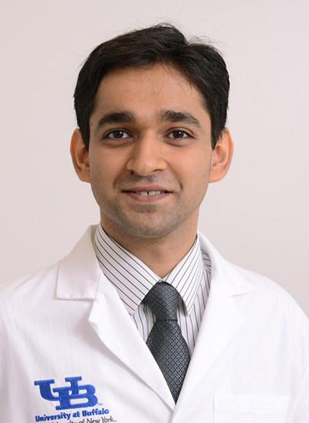

Dr. Harshit Shah was born and raised in Mumbai, India. He attended Krishna Institute of Medical Sciences University for Medical School where he received his MBBS degree in 2011. After graduation, he briefly worked at a tertiary care center in Mumbai: Bombay Hospital and Medical Research Center before moving to the US. Dr. Shah came to Buffalo NY in 2012 and since then has considered Buffalo as “home away from home”. He initially worked with the Vascular Neurology team at the GVI as a clinical observer in 2012. Dr. Shah then joined Dr. Szigeti’s lab at the CTRC as a Research Assistant where he worked on Genetics of Alzheimer’s Disease. He performed neuro-psychological tests on the research participants under the guidance of Dr. Benedict and his team. During that period Dr. Shah co-authored a case-report and Journal article in peer-reviewed Journals. Dr. Shah began his Neurology Residency at UB in 2014. After completion of Neurology Residency in 2018, Dr. Shah is proud to continue as Vascular Neurology Fellow at UB and is excit-ed to call Buffalo his home till 2019.

Outside work, Dr. Shah is a Cricket and Soccer enthusiast. He enjoys traveling and exploring new places and cuisines.

Introduction:

Statins are widely used for primary and secondary stroke prevention. Statins are known to have anti-inflammatory and anti-thrombotic properties. How-ever, statins have been considered to increase the risk of hemorrhagic strokes.

Objectives:

To assess effect of statin therapy and its dose relation prior to IV thrombolysis (IVT) for acute ischemic stroke (AIS) on rate of symptomatic intracerebral hemorrhage (sICH) and functional outcomes.

Methods:

This is a retrospective single center study. Patients were selected from our institutional database receiving IVT for AIS and were categorized based on their usage of Statin. Rate of sICH and outcomes were compared between statin users and nonusers. Statin users were further categorized into high in-tensity and low intensity statin subgroups. Poor outcome was defined as mod-ified Rankin Scale (mRS) of 3–6 on discharge, and sICH was defined as ICH with an NIH Stroke Scale (NIHSS) increase by at least 4 points.

Results:

834 patients received IVT for AIS. 51 patients had sICH (6.1%). 282 (33.8%) patients were on prior statin therapy. Incidence of sICH for statin group was 4.3% as compared to 7.0% for non-statin group. Multivariate analyses showed use of statin was not significantly associated with odds of sICH (OR: 0.52; 95% CI 0.26-1.03; p-value 0.06) when adjusted for Age, NIHSS history of DM and A.fib. No significant difference noted in the chance of poor functional outcome (OR 1.10; 95% CI 0.79-1.55; p-value 0.57). Use of high intensity statins was not associated with increased risk of sICH (OR 0.39; 95%CI 0.11-1.40; p-value 0.15). Use of high intensity was not associated with poor outcome (OR 0.60; 95% CI 0.35-1.05; p-value 0.07).

Conclusion:

Patients with AIS receiving any statins and high intensity statins were not at higher risk of developing sICH after IVT, neither did increase the chance of poor functional outcome.
IRB Approval:

Stroke Outcomes Research 425450-7

Conflicts of Interest:
Neither resident nor mentor have conflicts of interest to declare.

Disclosures:
Resident has no disclosures to declare.

Does Body Mass Index Impact the Outcome of Stroke

Patients who Received Intravenous Thrombolysis?

Daniela Zambrano, MD
Ashkan Mowla, MD
Robert Sawyer Jr., MD

University at Buffalo, Department of Neurology Jacobs School of Medicine and Biomedical Imaging
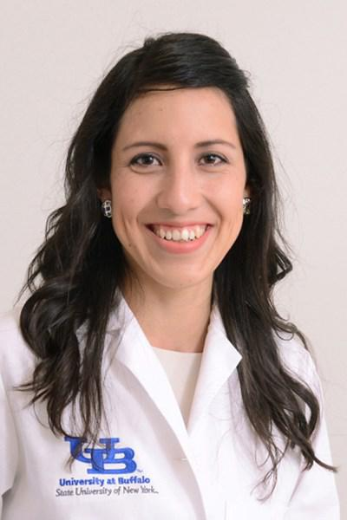

Daniela was born and raised in Quito, Ecuador. Following her family tradi-tion, she obtained her medical degree at the Pontificia Universidad Católi-ca del Ecuador where she was an active member of the university commu-nity. During the seven years of medical school, she volunteered in multiple projects, but she developed a particular interest in the ones related with education and medical brigades that targeted underserved populations in remote areas of the country.

She discovered her passion for Neurology early on; neuroanatomy opened an unexpected door to a fascinating field, her interest would only continue to grow in the following years especially after her work in rural areas showed her how little care people with neurological conditions were re-ceiving and how it affected their quality of life. After completing the man-datory year of rural medicine, she decided to look for the best training available to help her face the challenges of the complicated cases that she encountered on the previous year and finally decided to move to the Unit-ed States to pursue her dream of becoming a neurologist.

Daniela is currently finishing the last year of her Adult Neurology Residen-cy and is excited to start a Vascular Neurology Fellowship this summer at New York Presbyterian Hospital -Columbia.

Introduction:

Obesity has been shown to be an independent predictor of unfavora-ble functional outcome in acute ischemic stroke (AIS) patients treated with intravenous thrombolysis (IVT), but the number and sample size of the relevant studies are small. We aimed to evaluate the impact of body weight on outcome of AIS patients after IVT in a large cohort study.

Methods:

We retrospectively reviewed the medical records of the patients treat-ed with IVT for AIS in our center from the beginning of 2006 till the end of August 2015. Patients were categorized according to their body mass index (BMI) as underweight (<18.5 kg/m2), normal weight (18.5-24.9 kg/m2), overweight (25-29.9 kg/m2), obese (30 kg/m2 < kg/m2). Using uni- and multivariate analysis and after adjusting for confound-ing factors, we evaluated the effect of BMI on poor outcome (defined as modified Rankin Scale 3 to 6) at discharge and also occurrence of symptomatic intracerebral hemorrhages (sICH). sICH was defined as ICH with an increase in National Institute of Health Stroke Scale of at least 4 points.

Results:

A total of 834 patients received IVT for AIS in our center during a 9·6-year period. A total of 23 patients (2.8%) were underweight, 262 (31.5 %) had normal weight, 324 (38.9%) were overweight and 224 (27.0%) were obese. After adjusting for age, baseline NIHSS, mean systolic blood pressure before IVT, history of atrial fibrillation (AF) and history of diabetes, the BMI category did not significantly influence the rate of sICH after IVT (P=0.47). After adjusting for age, baseline NIHSS, history of AF and history of diabetes, no significant unfavorable outcome differences were found (P= 0.48).

Conclusion:

BMI was not associated with functional outcome and rate of sICH in AIS patients treated with IVT.

IRB Study Approval: 425450-7

Role of Initial EEG and Yield of Hypothermia in Neonates with Mild Hypoxic Ischemic Encephalopathy

Alok Singla, MBBS
Arie L. Weinstock, MD

University at Buffalo: Department of Neurology Jacob’s School of Medicine & Biomedical Science

Dr. Alok Singla completed his medical school and subsequently Otolar-yngology residency training at the University of Allahabad, India. After receiving an institutional license from the Pennsylvania Medical Board, he completed his NIH T32 post-doctoral fellowship in Pediatric Otolar-yngology at the University of Pittsburgh Medical Center.

He joined the University at Buffalo as a Child Neurology fellow in 2015 after completing his three years of General Pediatric residency train-ing at the Texas Tech University, El Paso. Dr. Singla has published sig-nificant research in both national and international journals.

He enjoys his time with family, travelling to different places, and en-joying basketball at UB.

Background

Neonatal hypoxic ischemic encephalopathy (HIE) remains a leading cause of newborn mortality& morbidity. Therapeutic hypothermia (TH) is the first effective treatment which has demonstrated improvement.

Purpose:

To evaluate the positive predictive value (PPV) of early EEG on brain MRI out-comes post TH and to investigate continuous video-EEG (CVEEG) parameters that could act as prognostic predictors for normal MRI.

Methods:

Records for 60 infants with GA ≥35 weeks (49 with Sarnat stage II, and 11 with Sarnat stage I were reviewed retrospectively. APGAR scores, fetal umbilical artery cord pH, and severity of HIE per Sarnat staging were obtained. EEG background grading and MRI score was done as per Barkovich et al. Online statistics tools used.

Results:

13% percent of babies had APGAR scores <5 at 10 minutes, and cord pH was

- 7.0 in 19%. 51 infants who underwent TH were used for our data analysis. Infants with cord pH < 7.0 had early EEG abnormalities in 75% and post cool-ing MRI abnormalities in 30%. A total of 22% infants who had EEG with mod-erate abnormalities were noted to have MRI changes after TH. The PPV of early EEG to determine MRI abnormalities in this sample was 22.5% (95% CI 15.8-31.1%). This PPV increased significantly to 62.5% (95% CI 32.4-85.2%) if early EEG had moderate background abnormalities. During TH and rewarm-ing, early EEG background was improved in 51% CVEEG monitoring. 27% had reduction in IBIs and 38% had improved VD and S/W cycle differentiation. MRI was normal in 73 % with VD and S/W cycle differentiation and 38% abnormal with improved IBIs.

Conclusion:

We conclude that early EEG grading can be a valuable tool in decision making for selecting infants for TH when clinical parameters are not conclusive. Im-provement in CVEEG findings can be a valuable tool in predicting post cooling MRI changes

Conflict of Interest / Disclosures Statement: There are no disclosures or con-flict of interest statements for any authors.

IRB approval: STUDY00001941

Evaluation of Psychosocial Needs in Patients with

Adult and Pediatric Neurofibromatosis

David Okonkwo, MD
Lorna Fitzpatrick, MD

University at Buffalo: Department of Neurology Jacob’s School of Medicine & Biomedical Science
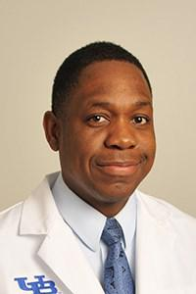

Dr. David Okonkwo obtained a Bachelor in Dental Surgery from the Uni-versity of Benin, Nigeria in 2006. He migrated to the United States and obtained his medical degree from the American University of Antigua in 2012, and an MBA from Plymouth State University New Hampshire. Dr. Okonkwo began his residency in 2013 and is currently in his 3rd year of the Child Neurology Residency program at the University at Buffalo.

David enjoys the study of music and global macro-economics.

Introduction/Background:

Children with NF are at increased risk for multiple psychosocial issues. The purpose of this study is assess the psychosocial needs of patients and the way NF effects their quality of life, which will inform various interventions that can be provided.

Previous Studies:

- Lehtonen suggests that the next step is to systematically assess aspects of executive functions and the nature of their deficits to elucidate the behavioral phenotype of these patients. This understanding would allow earlier and more efficient identification of children in need of remedial programs. (2) Esposito’s study on Pediatric NF 1 and parental stress speaks to the stress NF causes on mothers of these patients and how it effects family functioning. It suggests that psychological support as an intervention. (3) Garwood’s study also explored the psychosocial features of NF1 and concluded that there was a need to develop and assess psychosocial interventions for patients with NF1. Objective:

To quantify and better define the psychosocial needs in the adult and pediatric neurofibromatosis population, including an evaluation of their educational status, social interactions, peer relationships and psychosocial functioning. These data will be used to identify the population in need of intervention, and lead to the development of interventions and support methods.

Hypothesis:

There is no hypothesis, this study will assess the needs of NF patients. Methods:

Age-specific surveys will be given to all patients attending the monthly Neuro-fibromatosis Clinic in Buffalo, NY until 200 surveys are obtained. The surveys of all English-speaking, consenting patients and their parents will be included. Surveys were chosen based on publications verifying their validity and utility in specific age groups. These surveys consist of (1) the Child Behavior Checklist or Adult self-report, (2) the Pediatric Quality of Life Inventory, (3) the Pediatric QoL Inventory, Neurofibromatosis module, and (4) the Survey of Well Being of Young Children assessed by the Baby or Preschool Pediatric Symptom Check-list.
Expected Results:

We expect the data to define the psychosocial issues most burdensome to the neurofibromatosis patients, and will designate a population for future inter-ventions. Follow up studies would assess their efficacy.

Disclosures/Conflicts of Interest:

There is no funding and therefore no disclosures and no conflicts of interest. IRB Approval: Study 00001963

Can Frailty Measures be Added to Thrombolysis
Criteria to Enhance Decision-Making

Evelyn Berman, MD, Robert Sawyer, MD Steven Buslovich, MD, MSHCPM

University at Buffalo, Department of Neurology
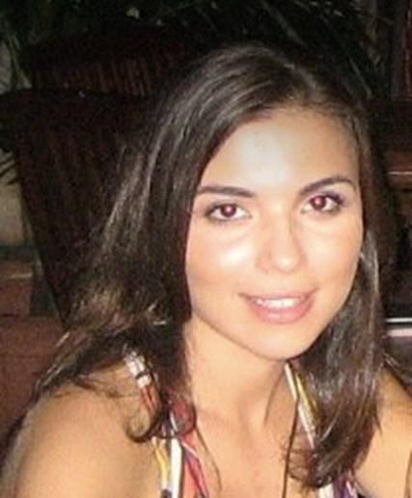

Dr. Evelyn Berman was born and raised in a small town in Ukraine. She moved to New York City at the age of 6 and started working hard toward her career in healthcare early. While studying at Hunter College in NYC, she earned a degree in Biochemistry and worked as a nutrition consultant. She then pursued her first research venture in Neuroscience at The Rockefeller University Institute where she performed stereotactic neurosurgery on rodents and studied the tissue ob-tained for neurogenesis. After spending countless hours in the lab, she soon real-ized that she had an interest for clinical medicine and decided to volunteer at Beth Israel Hospital. This was the impetus for her career in medicine and she is now a budding child neurologist and future neurophysiologist. She obtained a medical degree from the American University of Antigua in 2013, then ventured off to be a clinical liaison for a multi-center study called FEBSTAT at Children’s Hospital at Montefiore, under the brilliant guidance of Dr. Shlomo Shinnar. All of her accomplishments have led her to be a current 4th year child neurology fellow at the University of Buffalo. Dr. Berman is also married and a proud mom of two young boys. She values family above all else, she is also an avid traveler, loves fashion, film and music. Selecting mentors was not a challenge and she immedi-ately knew that Dr. Sawyer would be 100% supportive of her current project, along with Dr. Buslovich, who is not only her spouse, but also an inspiring medi-cal entrepreneur.

Introduction/Background:

The increasing number of patients with acute ischemic strokes raises interest in better identifying patients at increased risk of morbidity and mortality, independent of age. Frailty can be measured in relation to the number of deficits an individual has accumulated over their lifespan. It is a measure of physiological age rather than chronological age and understanding how it is measured allows for proactive approaches to appropriate early intervention with a subsequent reduction in poor clinical outcomes. Frailty indices may represent an important new contribution to prognostic models of stroke.

Objectives and Hypothesis:

To examine the impact of frailty on hospital length of stay (LOS), 30-day mor-tality post ischemic stroke after tPA, medical complications, discharge dispo-sition and disability at discharge. We anticipate that moderately-severely frail patients will have worse outcomes after receiving tPA.

Methods/Statistics:

Data will be collected and analyzed using an existing database of stroke pa-tients presenting to Gates Vascular Institute from January 1, 2016 - December 31, 2016. A retrospective chart review will be performed to assess post-admission electronic frailty index using Patient Pattern, a software used to calculate the frailty index. Baseline function will be measured with the Clinical Frailty Scale, pre-admission and post-discharge.

Expected Results:

Frail patients will have significantly worse scores at baseline & discharge, longer acute hospital LOS, increase in 30-day mortality, increase in medical complications and are more likely to be discharged to a nursing home.

IRB Approval: Pending

Conflict of Interest: Authors have no conflicts of interest to declare.

Disclosures: Neither Resident nor Mentor have anything to disclose.

VNS and Medication Combination In Controlling

Refractory Epilepsy
Zilfah Younus, MBBS,
Osman Farooq, MD

University at Buffalo; Department of Neurology Jacobs School of Medicine and Biomedical Science
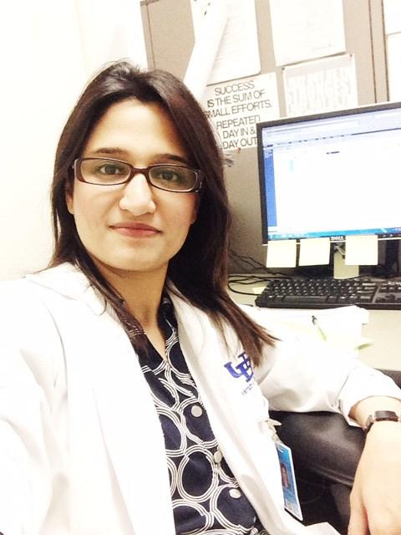

Dr. Zilfah Younus was born and raised in Lahore Pakistan. She obtained her medical degree from Islamic International Medical College, Islamabad Paki-stan. After completing her medical degree she worked as a medical officer at Pakistan Institute of medical sciences which is one of the biggest tertiary care hospitals in the area. Along the way she knew that she wants to follow foot-steps of her siblings who were already pursuing medical careers in the USA, her sister being a pediatrician and her brother now a critical care fellow at WASHU.

Dr. Younus came to the USA in 2013 and joined as a research assistant with Dr. Bianca Weinstock-Guttman and began to work on New York State Multi-ple Sclerosis Consortium. She was also able to present her poster at American Academy of Neurology Annual meeting in 2014. She was first author on a pub-lished an article under the mentorship of Dr. Guttman.

Dr. Younus joined Prelim year in Internal medicine in 2015 and continued her residency in Neurology in 2016. She will be graduating in 2019 and intends to do a fellowship in Headache Medicine and join her husband in New York City.

Background:

Over 70 million people are affected by epilepsy, a devastating and common neu-rological disorder. About one third of these patients have epilepsy that is resistant to pharmacotherapy. Drug resistant epilepsy is multifactorial and studies have shown that the chances of controlling seizures after the failure of a second AED decline sharply. Moreover, as more AEDs are added; a potential increase in side effects can be observed on brain as well as systemic organs. Lack of satisfactory seizure control, refractory epilepsy and side effects of AEDs pave the way for oth-er therapeutic avenues, such as, vagal nerve stimulation (VNS), deep brain stimu-lation, ketogenic diet and resective surgery,.

Objectives/Hypothesis

The primary aim of the study is to identify, among VNS responder patients, the combinations of antiepileptic drugs that result in the desired seizure control.

Methods/Statistics

Patients will be identified via a patient database maintained by Cyberonics, a com-pany that develops VNS therapy system. Data will be collected retrospectively from patient records, for seizure frequency prior to VNS placement as baseline and at 3 months, 6 months and 1 year follow up after VNS implantation. VNS data-base will be used to identify refractory epileptic patients who underwent VNS device implantation procedure, and also received a minimum of 3 AEDs. From this cohort, the patients with ≥50% reduction in seizure frequency (responders) at 6 month follow-up visit will be identified and separated from non-responders (patients <50% seizure frequency reduction at 6 month visit from baseline seizure frequency). Among the responder VNS group, percentage and frequency of re-duction in seizures will be calculated and the drug combinations which correspond with the reduction in seizures frequency will be identified.

Statistical analysis:

Data will be entered and analyzed in IBM SPSS version 21.0. Mean, median and standard deviations will be reported for continuous variables. Percentages and frequencies will be reported for categorical/dichotomous data.

Expected Results:

This study will provide valuable information on the AED combinations and their efficacy in reducing the seizure frequency among VNS responder patients.

IRB Approval: Pending

Conflict of Interest: Authors have no conflicts of interest to declare.

Disclosures: Resident has no disclosures to declare.

Effect of Feedback on Anosognosia

Evelyn Walsh, MD

Kinga Szigeti, MD, PhD

University at Buffalo; Department of Neurology Jacobs School of Medicine & Biomedical Science
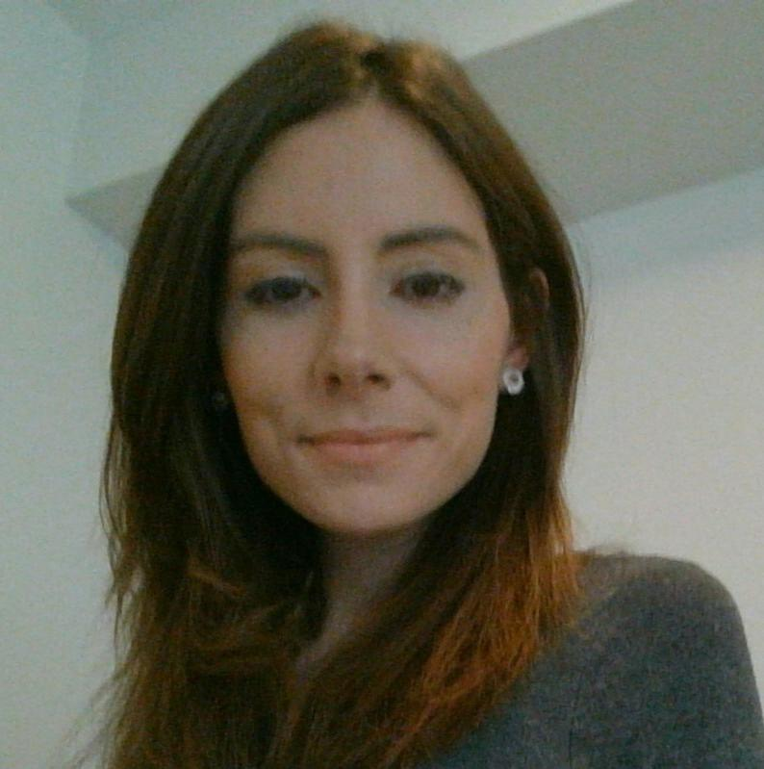

My name is Evelyn Walsh, and I obtained an MBBS at the University of Limerick, Ireland in 2015 following completion of BSc (Biochemistry) at University College Cork in 2010. I spent several months working for an investment bank in Dublin prior to transitioning to Research and Devel-opment, and ultimately to medical school. I am currently a PGY-3 resi-dent in neurology at University at Buffalo.

I became interested in neurology quite early in medical school as it seemed to me to be the field with the most unanswered questions. I’ve always been particularly interested in the subject of human personality and cognition, and considering the physiologic, genetic, and psychosocial factors that contribute to making us who we are. My other interests in-clude developmental disorders, human memory, and metabolic disease. Outside of work, I read, run, and spend most of my time with my two year old daughter, Zoe.

Background:

Anosognosia has been defined as the “apparent unawareness, misinterpretation, or explicit denial of an illness”, and it is frequently seen in patients with Alzhei-mer’s disease. Several studies have been undertaken to evaluate the hypothesis that anosognosia serves as a coping or defense mechanism to shield patients with dementia from depression. Although studies are inconsistent in demonstrating a relationship between anosognosia and major depressive disorder, there seems to be a negative correlation between anosgnosia and dysthymia, and a positive cor-relation with higher scores on the pathological laughing scale. No study to date has evaluated whether there is any relationship between personality traits and anosognosia.

Objectives:

This study aims to evaluate whether a relationship exists between anosognosia and personality traits, in addition to evaluating the impact of anosognosia on the neuropsychiatric inventory (NPI) and caregiver burden (measured via the RUD instrument).

Methods:

This will be a prospective observational study. Inclusion criteria for the study are an MMSE score greater than or equal to 22, age greater than 65, a diagnosis of amnestic MCI or probable Alzheimer’s disease, and male or female gender. Pa-tients with premorbid psychiatric disorders will be excluded from the study. Pa-tients will be administered the 30 item Anosognosia Questionnaire – Dementia (AQ-D) and NEOFFI, which will be used to determine whether there is a relation-ship between anosognosia and personality traits, in addition to evaluating wheth-er anosognosia accounts for any change in the neuropsychiatric inventory (NPI) or caregiver burden measured via the resource utilization in dementia (RUD) instru-ment. Regression models with NEOFFI as predictor and AQ-D as outcome, AQ-D as predictor and NPI as outcome, and AQ-D as predictor and RUD as outcome will be run. MMSE, age, sex and APOE status will be incorporated into the models as co-variates.

Expected Results:

We hypothesize that personality traits correlate with the presence or absence of anosognosia. We hypothesize that anosognosia in amnestic MCI/probable Alzhei-mer’s disease patients increases caregiver burden and healthcare utilization. We hypothesize that anosognosia increases the risk of behavioral psychiatric symp-toms of dementia as measured by the NPI.

IRB Approval: Pending

Conflicts of Interest: None

Benzodiazepine Administration in Psychogenic Non-

Epileptic Seizure and Subsequent ED Visits And Hospitalizations

Kevin Schmitt, MD
Ping Li, MD

University at Buffalo; Department of Neurology Jacobs School of Medicine and Biomedical Science
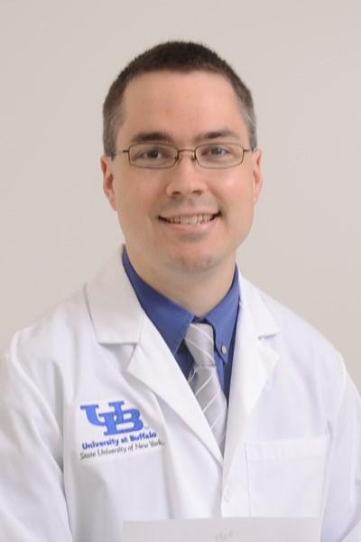

I was born and raised in Rochester NY. In high school I fell in love with learning about human evolution, which made me want to major in biology in college. In college I developed a passion for neuroscience and also physiology, which made me decide to go to medical school. I received my B.S. in Neu-roscience. I went to medical school at SUNY Downstate in Brooklyn NY where I decided that I wanted to keep learning about the brain and the mind, so I chose Neurology. My plan for my career is to work in a 100% outpatient setting in Gen-eral Neurology so that I can stay up to date with all of the neurologic diagnoses and also pay attention to one patient at a time.

Background:

It has been shown that patients with PNES receive higher cumulative doses of benzodiazepines in the ED than patients with epileptic seizures. Benzodiaze-pines are known to act on the Ventral Tegmental Area and the Nucleus Ac-cumbens, both known to be involved in reward anticipation and addiction. It has not been studied whether there is a relationship between the use of ben-zodiazepines in PNES and a subsequent higher rate of ED visits and hospitali-zations.

Objectives/Hypothesis:

We will evaluate whether individuals with PNES who are treated with benzo-diazepines have more frequent subsequent ED visits and hospital admissions than those who do not receive this treatment. The hypothesis is that the re-warding effect of benzodiazepine administration contributes to a positive re-inforcement of the behavior.

Methods:

We will retrospectively study the record of individuals diagnosed with PNES in the Epilepsy Monitoring Unit from 2007-2017 without a concurrent diagnosis of organic epilepsy. Patients’ electronic medical records will be used to collect demographic data including age and gender, comorbidities such as depres-sion, anxiety and PTSD, history of substance abuse, number of ED visits, num-ber of hospitalizations, and administration of benzodiazepines during both ED visits and hospitalizations. Patients will be divided based on whether a medi-cal provider has administered benzodiazepine for non-epileptic seizures. We will look for a statistical difference in subsequent ED visit and hospital admis-sion between those who did and did not receive treatment. A multivariate analysis will be used to ensure that any difference in comorbid conditions such as depression, anxiety, PTSD, substance abuse are not confounders in the above analyses.

Results:

We expect that individual who receive benzodiazepine in the ED and hospital setting early in the course of their disease will have higher rates of subse-quent ED visits and hospital admission than those who do not receive benzo-diazepine. We expect that there is a linear correlation between the cumula-tive dose of benzodiazepine use and subsequent ED visits and hospitalization rates.

IRB approval: Pending

Disclosures and Conflicts of Interest: None

Treatment of Headache in Acute and

Subacute Ischemic Stroke

Alise Pham, DO
Melissa L. Rayhill, MD, FAHS

University at Buffalo; Department of Neurology Jacobs School of Medicine & Biomedical Science
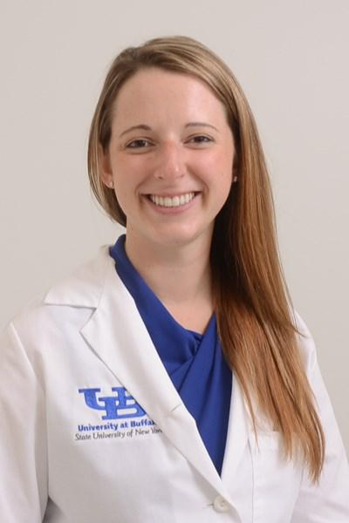

Dr. Alise Pham was raised in Elmira, New York. She graduat-ed magna cum laude from SUNY Fredonia with a major in chemistry and minor in biology. After her undergraduate studies, she matriculated into Lake Erie College of Osteo-pathic Medicine and where she earned her medical degree. Dr. Pham then couples matched with her husband to the University at Buffalo where she is currently a Neurology Resi-dent. She and her husband have become first time parents this past month. Following completion of Adult Neurology Residency, she is scheduled to begin a Headache Medicine Fellowship at Brigham and Women’s Faulkner Hospital.

Background:

Headache is a common symptom associated with patients experienc-ing acute and subacute ischemic stroke. Most commonly headache pain occurs after the onset of focal symptoms and is described as pres-sure-like or throbbing in nature. There are multiple proposed etiolo-gies to the pain associated with stroke including vessel wall integrity and pressure which may activate perivascular nerve fibers initiating pain. As the mechanism remains uncertain, the best treatment for pain in these patients is also unclear.

Objectives:

The object of this study is to survey patients after administration of analgesics used in treating headache associated with acute and sub-acute ischemic stroke and evaluate the patient’s pain level in response to treatment.

Methods:

Patients who are identified to have headache associated with acute and subacute ischemic stroke will receive a survey to document pain level. Patients will be asked to rate their pain on a visual analogue scale (VAS) ranging from 0-10. Patients will then evaluate their pain at 1, 3, 6, and 12 hours after administration of the analgesic medication. Enrolled patients must be able to communicate pain level either ver-bally or using the pictorials on the VAS. This study will also review the pain scores in relation to the patient’s last known well time.

Expected Results:

We believe this study will provide valuable information of patient ex-perience after administration of medications used to treat headache in ischemic stroke. We hope this prospective observational pilot study will lend itself to further randomized controlled trials to determine efficacy and safety of these medications in this clinical setting.

IRB Approval: Pending

Conflicts of Interest: None

Disclosures: None

Hair Lithium Levels in Cigarette

Smokers

Felix Cheng, MD
Thomas Guttuso, MD

University at Buffalo; Department of Neurology Jacobs School of Medicine & Biomedical Science
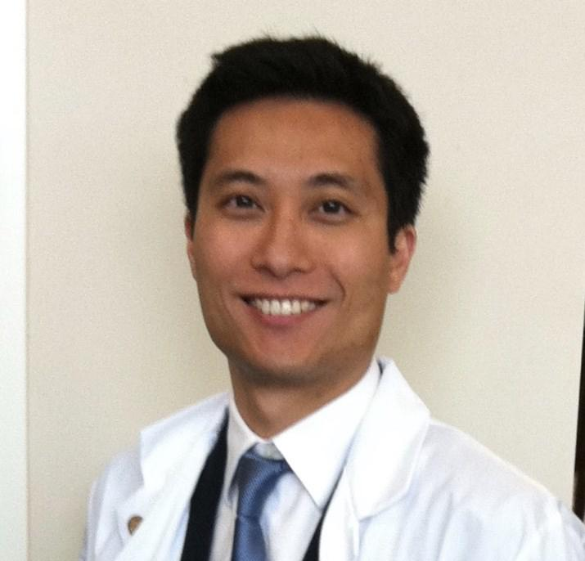

Felix was born in Hong Kong and moved to Toronto, Canada at the age of

- After completing his Bachelor of Science with Honors at Queen’s Uni-versity in Kingston, ON, he went on to become a physical therapist with a Master and Doctorate Degree through SUNY Upstate Medical University. After six fulfilling years of practicing physical therapy and as a profession-al practice leader at Toronto Rehab, Felix continues his professional jour-ney in the field of medicine. By attending St. George’s University School of Medicine, Felix experienced the culture and healthcare of England, the Caribbean, and the US. Felix is fascinated by the human mind and the organ that studies itself, the brain. His current interest is in the neuro-physiology of conscious awareness, information processing at the con-scious and the subconscious level and the mind-brain connection. Felix will continue his training at the University at Buffalo for the neurophysi-ology fellowship after residency. An avid single tennis player before mov-ing to Canada, Felix was no stranger to the sweet individual victories and the loneliness of defeat. Felix later fell in love with the game of basket-ball. Initially, he was attracted by the late game heroics and the acrobatic highlights, but being the student of the game, Felix realizes the true beauty of basketball lies in team work, comradery and “the whole is greater than the sum of its parts”.

Background:

Idiopathic Parkinson’s disease (IPD) is the second most common neurodegenera-tive disease in the US. Despite many effective treatments for managing Parkin-son’s symptoms, there is no approved disease modifying therapy. Tobacco smok-ing has consistently been associated with a 30-70% reduced risk of developing IPD in over 60 epidemiological studies. Certain compounds in tobacco may potentially be neuroprotective. Nicotine, a well-known compound in tobacco, has demon-strated neuroprotective action in animal models but negative in human clinical trials to date. Lithium is another compound found abundantly in US tobac-

co. Several epidemiological studies have shown significantly reduced rates of dementia in bipolar patients receiving lithium compared to bipolar patients re-ceiving anticonvulsant, antidepressant or antipsychotic medications. Moreover, two prospective, randomized, double-blinded, placebo-controlled trials have shown low-dose lithium therapy to provide significant improvements to cognition in patients with either mild cognitive impairment (MCI) or early Alzheimer’s dis-ease (AD). These studies suggest that lithium may be neuroprotective in slowing or preventing neurodegenerative diseases. Inhaled lithium from cigarette smoking may partially account for the strong inverse association between smoking and risk of developing IPD. However, the relationship between cigarette smoking and the amount of lithium absorbed into circulation remains unknown.

Objectives:

This study aims to examine lithium absorption from cigarette smoking by as-sessing lithium levels in hair (which is a sensitive measure of chronic lithium expo-sure), between age and sex matched smokers and non-smokers.

Methods:

This study will enroll minimum 10 adult subjects: 5 subjects who report smoking at least 1 pack-per-day for a year and 5 age and sex matched control non-smokers. Smokers will need a positive urine nicotine/cotinine test (>200ng/ml) while non-smokers will need a negative test (<10ng/ml) and report no use of any tobacco or nicotine products for at least the previous 6 months in order to be eligible. In addition, all subjects will need to deny use of any lithium medications or supplements for over 1 year. The occupation of the subjects and the amount of smokers in the household will be collected to account for potential passive tobacco exposure. Hair samples will be analyzed for lithium level and Paired stu-dent t-test will be used for statistical analyses.

Results:

We anticipate significantly higher hair lithium levels in smokers than non-smokers.

Conclusion:

Positive results from this study will show, for the first time, that lithium in tobacco is absorbed via inhalation and supports the hypothesis that increased systemic lithium levels in smokers may be one reason accounting for the markedly reduced rates of IPD in smokers.

IRB status: Pending

Disclosures: Authors have nothing to disclose

Stroke in Cancer Patients

Edina Komlodi-Pasztor, MD, PhD

Marilou I. Ching, MD, MPH, FACP

University at Buffalo, Department of Neurology Jacobs School of Medicine and Biomedical Science
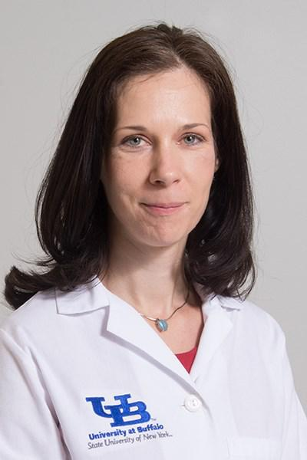

Dr. Komlodi-Pasztor received her medical degree in 2005 from the Semmel-weis University, Hungary. She has been interested in research from her early university years and participated in basic and clinical studies as a medical student. She successfully applied to the prestigious MD-PhD scholarship and became one of eight awardees in 2004. As part of her PhD work, Dr. Komlodi -Pasztor joined the laboratory of Dr.Tito Fojo at NIH/NCI in 2006. She re-ceived the PhD degree in 2011 and continued working at NIH. In 2013, Dr. Komlodi-Pasztor joined O&O Alpan, to establish a basic research laboratory and manage translational and clinical research, including investigator initiat-ed studies and sponsored trials. She joined Virginia Cancer Specialists and became the clinical research lead at the largest satellite site of the company between 2014 and 2016. She moved to Buffalo, NY to start her residency training at University at Buffalo, Neurology Residency Program in 2016. She is the first author of multiple peer-reviewed articles, one of which was se-lected among the “Top 10 must read articles on targeting agents” by the editors of Nature Reviews Clinical Oncology. Dr. Komlodi-Pasztor is passion-ate about combining her medical knowledge and research experiences for the benefit of advanced patient care.

Background:

Cancer is associated with a hypercoagulable state as well as an increased risk of bleeding. Compared to the general population, patients with cancer have an increased tendency for venous thromboembolism and arterial embolism as well as an increased risk for bleeding. As a result, making clinical decisions about anticoagulation has been challenging, and the complexity of the ques-tion is increased with the availability of multiple different drugs. While treat-ment guidelines have been established for the management of venous throm-boembolism, there is no evidence-based guideline available for the preven-tion of arterial embolism and thrombosis, such as stroke, in cancer patients.

Objective:

We aim to investigate the intrinsic and extrinsic factors that may play a role in the development of stroke in cancer patients.

Method:

Chart review of electronic medical records will be conducted to identify stroke patients with active cancer diagnosis who were treated at Buffalo Gen-eral Hospital between January 2010 and December 2017. Electronic medical records, including but not limited to results from diagnostic tests and notes from health service providers, will be used for data collection. The collected data will be used for further analysis in order to identify intrinsic and extrinsic factors that may play a role in the development of stroke in cancer patients.

Expected results:

By conducting this retrospective chart review study, our knowledge about stroke in cancer patients will increase. Ultimately, the emerged knowledge from this study will help to better understand stroke in cancer patients and will lead to information to guide the clinical decision of anticoagulation in cancer patients.

Ethics:

The study protocol and all other relevant documents will be submitted to the IRB for review, and approval will be obtained before the study is initiated per required guidelines. This study will be conducted with responsible clinical research practiced in accordance with local and national guidelines, regula-tions, and requirements.

Disclosure: Research staff has no conflict of interest to disclose

IRB Approval: Pending

Disclosures:

Ashkan Mowla, MD -

Member, Steering committee for Medtronic Diagnostics for FDA ap-proved indications for Reveal LINQ ICM. Dr. Mowla is a member, Johnson
- Johnson pharmaceuticals,Inc. speaker bureau and advisory board. He also serves as the site-PI on industry funded research projects NAVI-GATE ESUS and STROKE-AF.

Bianca Weinstock-Guttman, MD -

Bianca Weinstock-Guttman received honoraria as a speaker and as a consultant for Biogen Idec,Teva Pharmaceuticals, EMD Serono, Gen-zyme, Sanofi, Novartis and Acorda. Dr Weinstock-Guttman received re-search funds from Biogen Idec, Teva Pharmaceuticals, EMD Serono, Genzyme, Sanofi, Novartis, Acorda.

No additional disclosures.

NOTES: _______________________

_______________________________

_______________________________

_______________________________

_______________________________

_______________________________

_______________________________

_______________________________

_______________________________

_______________________________

_______________________________

_______________________________

_______________________________

_______________________________

_______________________________

_______________________________

_______________________________

This program was produced with the support of:

The Buffalo Neuroimaging Analysis Center (BNAC).

Graduation Dinner:

The Hotel Lafayette - Greenhouse Room

391 Washington Street
Buffalo, NY 14203
June 8, 2018

6:00 pm

Cocktails

7:00 pm

Dinner

Adult Neurology Resident Program
Director’s Introductions and Comments:

Nicholas J. Silvestri, MD

Chairman’s Address:

Gil I. Wolfe, MD, FAAN
Neurology Resident Research Program Director’s
Comments:

Robert Zivadinov, MD, PhD, FAAN, FANA, FEAN Michael E. Cohen Research Day Awards Presentation:

Michael E. Cohen, MD

Graduation Ceremony for Graduating Residents &

Fellows:

Nicholas J. Silvestri, MD
Adult Neurology Resident Program Director;
Marilou Ching, MD, MPH
Vascular Neurology fellowship Program Director

Sarah Finnegan, MD, PhD
Child Neurology Resident Program Director;
Ping Li, MD

Clinical Neurophysiology Fellowship Program Director;

Margaret Paroski, MD
Director, Neurology Clerkship

Message from Outgoing Chief Residents:

Sandhya Mehla, MBBS & Daniela Zambrano, MD

Message from Incoming Chief Resident

