2017
Michael E. Cohen
Residents
Research Day

State University of New York at Buffalo, Department of Neurology, Jacob’s School of Medicine and Biomedical Sciences

Friday, June 9, 2017 11:30 am—4:00 pm Cummings Conference Center

Graduating Residents

Ashish Arora, MBBS Adult Neurology, PGY4 (Chief Resident)

Svetlana Primma-Eckert, MD Adult Neurology, PGY4 (Chief Resident)

Hao Cheng, MD

Adult Neurology, PGY4

Brian Trummer, MD, PhD Adult Neurology, PGY4

PGY IV Residents 2017-2018

David Okonkwo, MD Child Neurology, PGY4

Alok Singla, MBBS Child Neurology, PGY4

PGY III Residents 2017-2018

Muhammad Ahmed, MBBS Adult Neurology, PGY3

Harshit Shah, MBBS Adult Neurology, PGY3

Sandhya Mehla, MBBS
Adult Neurology, PGY3

(Incoming Chief Resident)

Daniela Zambrano, MD
Adult Neurology, PGY3

(Incoming Chief Resident)

State University of New York at Buffalo,

Department of Neurology,
Jacob’s School of Medicine and Biomedical Sciences

2

Welcome/Introduction

11:30 am Gil I. Wolfe, MD, FAAN

Robert Zivadinov, MD, PhD, FAAN Nicholas J. Silvestri, MD

Presentation Session # 1

11:40 am Alok Singla, MBBS
12:00 pm David Okonkwo, MD
12:20 pm Muhammad Ahmed, MBBS
12:40 pm Break/Lunch

Presentation Session # 2

1:20 pm Harshit Shah, MBBS
1:40 pm Sandhya Mehla, MBBS
2:00 pm Hao Cheng, MD
2:20 pm Break/Photo Session

Presentation Session # 3

2:40 pm Ashish Arora, MBBS
3:00 pm Svetlana Primma-Eckert, MD
3:20 pm Brian Trummer, MD, PhD
3:40 pm End of presentations

3

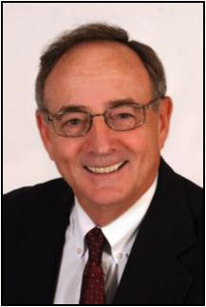
Michael Cohen, MD, Professor of Neurology and Pediatrics, State University of New York at Buffalo; Department of Neurology, Jacob’s School of Medicine and Biomedical Sciences

Research day in the Department of Neurology is always auspicious, for the residents and faculty alike. It is a time to reflect on the years spent at this University and the influence that your peers and the faculty have had on your development as sophisticated physicians.

Today, for the graduating seniors, marks a new beginning, a transition from student to fully-trained neurologic physician. I suspect the journey for many has been marked by joy and stress, doubt and attribution and above all pride, in your accomplishment.

As a faculty, we are delighted at your development and the list of all of your accomplishments. Your group has been recognized as teachers, authors and caring physicians.

As you move on in your life's journey, remember well the gifts given to you by this University. Continue to study and learn, honor your patients and as demonstrated to us, your teachers, "be all you can be".

We will miss you but recognize that we have helped you prepare for the future. Do well and stay in touch!

Michael E. Cohen, MD, FAAN, FANA, is a Professor of Pediatrics and Neu-rology. Dr. Cohen was Chair of the UB Neurology Department from 1983-2000. He is a past President of the Child Neurology Society, The Associa-tion of Child Neurology Professors and past President of the Section of Child Neurology of the American Academy of Neurology. He has been responsible for several of the all-day child neurology courses given at the annual meeting of the academy. He was a member of the organizing committee of the ABPN for neurodevelopmental neurology and has served on the writing committee for recertification for child neurology of the ABPN. His research interests have been primarily in neuro-oncology.

4

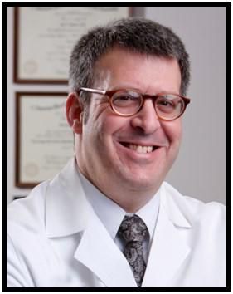
Gil I. Wolfe, MD, FAAN Chair, Department of Neurology University at Buffalo; Jacob’s School of Medicine and Bio-medical Sciences.

Welcome to the Michael E. Cohen, M.D., Resident Research Day; the annual event held by the University at Buffalo’s Department of Neurol-ogy staged in recognition of research projects conducted by our resi-dents and fellows. This year’s event is of special note given Dr. Co-hen’s semi-retirement. He will continue to teach on behalf of our de-partment and medical school.

Our research day represents the culmination of months and even years of meticulous work by our neurology trainees. This work is now subjected to peer scrutiny and competition for awards.

Moreover, the research day recognizes the involvement of our faculty and fellows in the mentorship of residents. Experience and lessons learned are passed from each generation of physician researchers to the next in just this way.

Through the years, graduates of our program have repeatedly con-firmed the invaluable experience of their participation in the Research Day. Their comments express an increased appreciation not only for the clinical research process itself but also for the positive impact it will always have on their clinical careers.

Today's presentations continue an established tradition of academic excellence. Please join the entire UB Department of Neurology in commending each resident and fellow for the innovation, scope and execution of their projects. On display are analytical skills, judgment and integrity. Please also accept my sincere appreciation to all of you for contributing to and sharing the day's events.

Best,
Dr. Wolfe

5

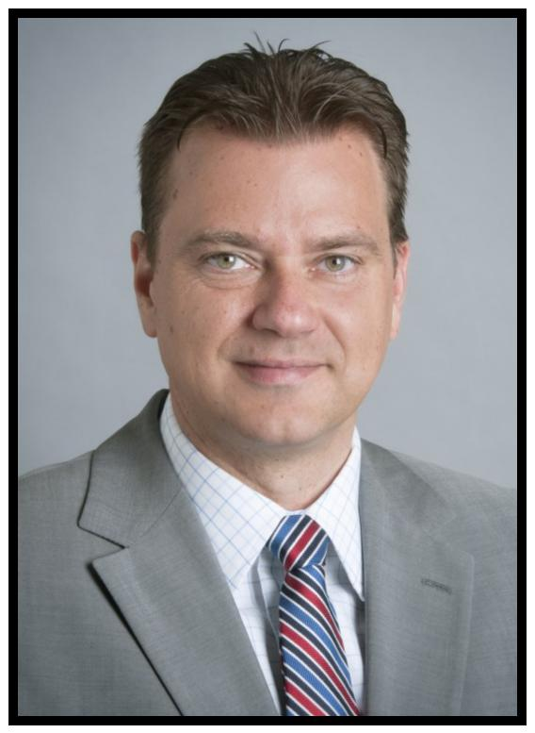
Robert Zivadinov, MD, PhD, FAAN,
FANA, FEAN
Resident Research Training

Program Director
Professor of Neurology,
State University of New York at
Buffalo; Department of Neurology
Jacob’s School of Medicine and
Biomedical Sciences

BNAC Director
MR Director of Imaging, CTRC

Thank you for joining us for the fourteenth annual Residents Re-search Day, and congratulations to our participants. Once again, these fine residents offer a wide scope of projects to be presented today, displaying knowledge, resourcefulness, deter-mination, and commitment to their field.

Whether our presenters’ careers lead towards clinical work or fur-ther research, they are true scholars, having exhibited the dis-cernment, intuition and drive that will guide them in future years. I congratulate each and every one of them for a job superbly done.

It has been my primary purpose these last few years to foster and facilitate an expansion of project diversity. As you see in your program today, although we continue to foster study in the areas of our strength and mainstays – stroke and multiple sclerosis – we continue to increase the number of projects that explore other neurological disorders and diseases.

With these additional advancements, we hope to “pave the way” to new levels of research distinction. Projects that are pro-gressively far-reaching and innovative will considerably advance the careers of our new physicians as well as enhance both the importance and notoriety of our Neurology Residency Program. What a wonderful endeavor to be part of!

6

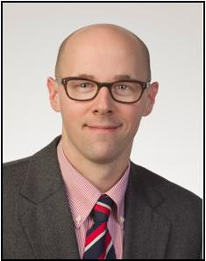
Nicholas J. Silvestri, MD, Associate Professor of Clinical Neurology Program Director, Adult Neurology Residency, State University of New York at Jacob’s School of Medicine and Biomedical Sciences

It gives me great pleasure to see yet another class of resi-dents graduate from our training program. Over the past three years, we have watched these individuals grow into outstanding clinicians, teachers, and scientists. I am cer-tain that they will continue to make us proud.

As the end of another academic year approaches, I am inspired by the enthusiasm and fortitude of our trainees. I would like to thank all of our residents for their hard work and dedication. I would also like to thank the faculty for their devotion to teaching and their support of the training program.

Finally, I would like to acknowledge the outstanding efforts of Ms. Eva Tamoga and Mr. Tom Bellanca who work tireless-ly in support of the program.

A native of Western New York, Dr. Silvestri has been on faculty in the De-partment of Neurology since 2009 and Program Director of the Adult Neurology Residency since 2011.

7

Role of Initial EEG and Yield of Hypothermia in Neonates with Mild Hypoxic Ischemic Encephalopathy

Alok Singla, MBBS
Arie L. Weinstock, MD

University at Buffalo: Department of Neurology Jacob’s School of Medicine & Biomedical Science
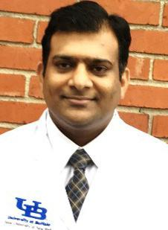

Dr. Alok Singla completed his medical school and subsequently Otolaryngology residency training at the University of Allahabad, India. After receiving an institutional license from the Pennsylva-nia Medical Board, he completed his NIH T32 post-doctoral fellowship in Pediatric Otolaryngology at the University of Pittsburgh Medical Center.

He joined the University at Buffalo as a Child Neurology fellow in 2015 after completing his three years of General Pediatric residency training at the Texas Tech University, El Paso.

Dr. Singla has published significant research in both national and international journals.

He enjoys his time with family, travelling to different places, and enjoying basketball at UB.

8

Background

Neonatal hypoxic ischemic encephalopathy (HIE) remains a leading cause of newborn death and long-term neurological disability. Thera-peutic hypothermia is the first effective treatment for moderate to severe HIE.

Objectives:

- To determine the yield of initial EEG as a deciding factor to undergo whole-body hypothermia in patients with mild HIE

- To determine the individual and combined predictive value of EEG (baseline and change within 72 hours), APGAR scores, severity grad-ing of HIE scoring as per Shankaran guidelines and MRIs at 72 hours with the 6 month cognitive and motor outcomes in infants with mild
HIE

- To determine the yield of video-EEG monitoring for 48-72 hours in seizure detection, when no seizures were recognized within the initial 24 hours

Methods:

EEG: At our institution, parents of infants fulfilling the criteria of HIE are approached for therapeutic cooling within 6 hours of birth. All patients undergo a baseline 30 minute EEG, 72 hour video-EEG during the cooling protocol. Baseline EEGs will be graded for severity based on back-ground activity and presence of seizure.

Brain MRI: MRI will be classified as normal to mild MRI injury as basal gan-glia/thalamus score <2 and watershed score <3 and moderate to severe as basal ganglia/thalamus score ≥2 or watershed pattern ≥3 (involving both sides).

Developmental assessments: The Cognitive Adaptive Test and Clinical Linguistic and Auditory Milestone Scale (CAT/CLAMS) and Alberta Invol-untary Movement Scale (AIMS) will be used.

Expected results:

It is expected that no severe EEG background changes or EEG seizures will be seen on baseline EEG in infants with mild HIE. EEG baseline and specific changes within 72 hours are poor predictors for 6 months out-comes in infants with mild HIE. If no seizure identified during first 24 hours, there will be no need for 48-72 hours monitoring; 6-hour EEG during re-warming would be sufficient.

Conflict of Interest /Disclosures Statement: There are no disclosures or conflict of interest statements for any authors.

IRB approval: Pending

9

Evaluation of Quality of Life Assessments and

Establishing Needs: Adult and Pediatiric
Neurofibromatosis

David Okonkwo, MD
Lorna Fitzpatrick, MD

University at Buffalo: Department of Neurology Jacob’s School of Medicine & Biomedical Science
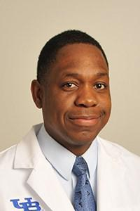

Dr. David Okonkwo obtained a Bachelor in Dental Surgery from the University of Benin Nigeria in 2006. He migrated to the United States and obtained his medical degree from the American University of Antigua in 2012, and an MBA from Plymouth State University New Hampshire. Dr. Okonkwo began his residency in 2013 and is currently in his 4th year of Pediatric neurology training in the University of Buffalo Child neurology program.

David enjoys the study of music and global macro-economics.

10

Background:

Neurofibromatosis (NF) is a devastating neurological disease that affects pa-tients in many dimensions of their lives. The most important recognized end-points for NF trials are pain, functional ability and cognitive function, all of which affect a patient’s quality of life. This has been determined by the Pa-tient Reported Outcomes segment of an international organization called REiNS: Response Evaluation in Neurofibromatosis and Schwannomatosis. This organization is charged with identifying research outcomes that patients deem to be the most important, thus guiding current research trends.

Objectives:

To investigate quality of life (QoL) measures of pain, physical and cognitive function in an adult and pediatric NF population.

Methods:

The population will be a cross section of patients of all ages attending the Neurofibromatosis clinic at Women and Children’s Hospital of Buffalo over a one-year period. We will collect the following data of QoL:

- Average pain level, using, for age 8yrs to adult, the 11-point Numeric Rating Scale (0-10); for ages 3-7yrs, the Faces-revised scale, and; for be-low 3 yrs of age, the FLACC scale.

- Physical functionality, using the Child Behavior Checklist 11/2-5 and 6-18, a section of the Rand Short Form-36 Health Survey that addresses physi-cal function as related to illness, Q3-16; and/or Peds QL.

- Cognitive function, using the Behavior Rating Inventory of Executive Func-tion (BRIEF) surveys for adults, children and teens, and/or Peds QL.

Expected Results:

We expect to show that patients with NF will fall above the normative data of pain, and below the normative data for physical and cognitive functioning. The likelihood that this is not due to chance will be proven by the Independ-ent T-test. This data will be used to identify the subpopulation of NF patients in need of immediate intervention as well as guide future studies on interven-tions that would be most beneficial to this population.

Disclosures/Conflicts of Interest:

Neither the resident nor the mentor has any disclosures to make or any con-flicts of interest, as this study is not funded.

IRB Approval:

Pending.

11

Role of Tonsillectomy on Clinical Presentation of Multiple Sclerosis and Treatment Response

Muhammad Khaleeq Ahmed, MBBS
Bianca Weinstock-Guttman, MD

University at Buffalo, Department of Neurology Jacobs School of Medicine and Biomedical Sciences
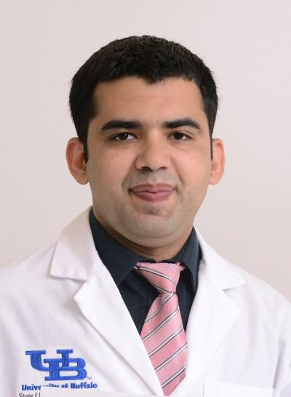

Dr. Ahmed is a PGY-3 resident at the UB Neurology residency pro-gram. He grew up in Bahawalpur, a relatively small town in Paki-stan, but rich in educational and cultural heritage. He complet-ed his medical school from his home town at QAMC in 2010. After completing rotating internship, he worked at a small medical center serving underserved communities, which inspired him to pursue advanced training.

His journey away from his home country started with his work in highly advanced, Neuroimaging lab at Thomas Jefferson Universi-ty, Philadelphia, under Dr. Joseph Tracy, where his work involved studying role of fMRI and DTI in evaluating language function with temporal lobe epilepsy. Later on he worked with Dr. Ching and Dr. Sawyer, as a research associate, stroke research division at Gates Vascular institute, where he was involved in different pro-jects including stroke outcome measures.

He enjoys reading, especially history, movies and spending time with family, especially his new born son. His research interests in-clude cerebrovascular disease and demyelinating disorders. Dr. Ahmed is excited to continue as a vascular neurology fellow at University of Texas at Houston.

12

Background:

Multiple sclerosis is an immune mediated demyelinating disease with involvement of lymphoid tissue, in terms of activation of T-cells and B cell, and lymphoid tissue especially tonsils including palatine and adenoid, are involved in activation of T-cell along with regulatory B Cells, which is involved in pathogenies of multi-ple sclerosis.

Objective:

To find the effect of tonsillectomy on incidence of multiple sclero-sis, progression, different presentation and treatment response with different type of drugs, along with incidence of Epstein Barr Virus infection.

Method:

This study will be conducted as retrospective case control in sin-gle multiple sclerosis center, with patients of multiple sclerosis to compare incidence age, age of surgery, disease presentation, type, treatment response and history of EBV infection will be com-pared in patients with tonsillectomy in comparison to patients without tonsillectomy with adjustment of age, gender, ethnicity, and disease type after creating statistical analysis model.

Expected Results:

It is expected that tonsillectomy has role on incidence age, initial presentation and treatment response with specific medications. The meaningful results will help in understanding clinical presenta-tion and guide in treatment choice in patients who had under-gone tonsil removal surgery, especially in terms of different medi-cations with understanding of history of EBV virus infection.

IRB approval Pending

Conflicts of Interest: Authors have no conflicts of interest to de-clare.

Disclosures: Authors have no disclosures relevant to the study.
Please see page 26 for additional information.

13

Effect of Statins on Intracerebral Hemorrhage and Outcome After IV Thrombolysis for Acute Ischemic Stroke

Harshit Shah, MBBS
Ashkan Mowla, MD, FAHA, FAAN

University at Buffalo, Department of Neurology Jacobs School of Medicine and Biomedical Science
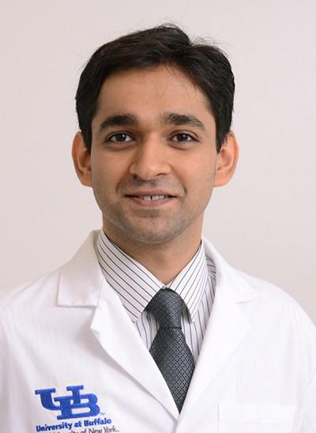

Dr. Harshit Shah was born and raised in Mumbai, India. He attended Krishna Institute of Medical Sciences University for Medical School where he received his MBBS degree in 2011. After graduation, he briefly worked at a tertiary care center in Mumbai, Bombay Hospital and Medical Re-search Center before moving to the US. Dr. Shah came to Buffalo in 2012

and since then has considered Buffalo as “home away from home”. He

initially worked with the Vascular Neurology team at the Gates Vascular Institute as a clinical observer in 2012.

Dr. Shah then joined Dr. Szigeti’s lab at the CTRC as a Research Assistant where he worked on Genetics of Alzheimer’s Disease. He performed neuro-psychological tests on research participants under the guidance of Dr. Benedict and his team. During that period Dr. Shah co-authored a case report and Journal article in peer-reviewed Journals.

Dr. Shah started his Prelim year in Internal Medicine at UB in 2014 and continued his Residency in Neurology in 2015. During his training, Dr. Shah developed interest in Vascular Neurology and Epilepsy. He decided to pursue his research interests and future career in Vascular Neurology. After completion of Neurology Residency in 2018, Dr. Shah is proud to join the Vascular Neurology Fellowship at UB and is excited to call Buffalo his home until 2019.

14

Introduction:

Statins are widely used for primary and secondary stroke preven-tion. Apart from Cholesterol lowering properties, statins also have antithrombotic properties. However, statins have been consid-ered to increase the risk of hemorrhagic strokes. Recently, data has suggested that previous use of statins by patients getting IV thrombolysis (IVT) for acute ischemic stroke might increase the risk of symptomatic intracerebral hemorrhage (sICH). This data is in-conclusive and conflicting. Limited data exists for evaluation of dose related effects on sICH after IVT.

Objectives:

We would like to study if the use of statins prior to IVT has in-creased risk of causing sICH. We also aim to determine the dose related effects of Statins on sICH after IVT. Evaluate effects of Statins and its Dosage on Poor Outcomes.

Methods:

This is a retrospective single center study. Patients will be selected from our database receiving IV tissue plasminogen activator (tPA) for AIS and categorize them based on their usage of Statins. Pa-tients with sICH after receiving IVT will be analyzed based on im-aging, NIHSS and discharge mRS.

Demographic information, NIHSS at admission, medical history, medication history and pertinent lab values will be noted.

Expected Results:

Since there is limited data on prior Statins use, possibility of sICH and Poor Outcome after IVT and dose related effects; this re-search will help shed some light on this topic.

This study will potentially enable us to answer the following:
Risk of sICH after IVT for patients on Statins.

Dose related effects of Statins to sICH after IVT. Prior use of Statins related to poor outcome.
Dose related effects of Statins on poor outcome.

IRB Approval:

Stroke Outcomes Research 425450-7

Conflicts of Interest:

Neither resident nor mentor have conflicts of interest to declare.

Disclosures:

Resident has no disclosures to declare. Please see page 26 for additional disclosure information.

15

Patient is Taking Antiplatelet at home-

Does This Increase the Risk of Post Intravenous Thrombolysis Intracranial Hemorrhage?

Sandhya Mehla, MBBS
Navdeep Lail, MBBS, Ashkan Mowla, MD, FAHA, FAAN

University at Buffalo, Department of Neurology Jacobs School of Medicine and Biomedical Science
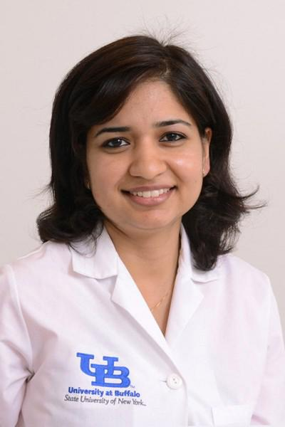

Sandhya was born and raised in Kurukshetra, India. She obtained her Medical degree from M. P Shah Government Medical College, Jamnagar, Gujarat, India in 2010. Sandhya has worked in India as a Medical Officer under National Ru-ral Health Mission and as a Junior Resident in Neurology department at an Academic Multispecialty Hospital. She then moved to the United States and joined the Stroke Research department here at UB. She was appointed as a research assistant and worked on various ongoing clinical trials and new re-search projects including resident research projects in previous years.

Sandhya joined UB Neurology Residency program in 2015 after completing her internship at UB Internal Medicine Program. Her research interest is in Vascular Neurology. She presented her resident research project as a poster at the International Stroke Conference 2017. She also co-authored 4 publica-tions and multiple abstracts presented at various National and international conferences. Sandhya wants to pursue her career in Vascular Neurology and she has matched in the Vascular Neurology fellowship program at University of Massachusetts, which she will be joining in 2018. Besides being UB resi-dent’s committee representative, she is also a member of UBRC steering com-mittee. Sandhya will be one of the Chief residents for the upcoming academic year.

16

Introduction:

Antiplatelet drugs are frequently being used by patients with acute ischemic stroke (AIS). This study aims to assess whether tak-ing Antiplatelet prior to intravenous thrombolysis therapy (IVT) in AIS will have any effect on the functional outcome and rate of sICH.

Methods:

A retrospective chart review was conducted on patients treated with IVT for AIS at our center from 2006 to 2016. Patients who were taking at least one antiplatelet before AIS were identified. Rate of sICH and good outcome were compared between antiplatelet users and non-users. Poor outcome was defined as modified Ran-kin Scale (mRS) of 3-6 at discharge, and sICH was defined as ICH with an increase in the National Institutes of Health Stroke Scale of at least 4 points.

Results:

834 patients received IVT for AIS. 51 patients (6.1 %) developed sICH. A total of 358 patients (42.9%) were taking at least one an-tiplatelet drug when the AIS occurred. 51 (6.1 %) were on dual antiplatelet therapy (Aspirin and Clopidogrel). 21 (5.8%) among antiplatelet users developed sICH. The incidence of sICH was

5.8% for Aspirin 81 mg group, 4.05% for Aspirin 325 mg, 4.1 % for Clopidogrel, 3.9 % for combination Aspirin and Clopidogrel, none for combination of ASA and dipyridamole and 6.1 % for those on no antiplatelet drugs. In multivariable analyses, when adjusted for age, baseline NIHSS and history of diabetes, use of antiplatelets was not associated with increased sICH (odds ratio, 0.834; 95% CI, 0.457 to 1.520; p-value=0.553) and no significant difference in the chance of having poor functional outcome was noted (Odds ratio, 1.182; 95% CI, 0.859-1.627; p-value=0.305).

Conclusion:

Patients with AIS receiving long-term antiplatelet medications were not at greater risk of developing sICH after systemic IVT. These patients don’t have increased chance of having a poor functional outcome when treated with IVT.

IRB approval #MODCR00000144

Conflicts of Interest: Authors have no conflicts of interest to de-clare.

Disclosures: Authors have no disclosures relevant to the study.

Please see page 26 for additional information.

17

Analysis of Heart Rate Variability During

Nocturnal Seizures

Hao Cheng, MD
Sarah Muldoon, PhD, Arie L. Weinstock, MD

University at Buffalo; Department of Neurology Jacobs School of Medicine & Biomedical Science
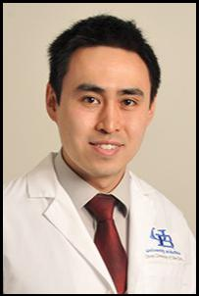

Dr. Cheng was interested in sciences since childhood grow-ing up in Ottawa, Canada. He went on to study electrical engineering at The University of Illinois, Urbana-Champaign for college. Afterwards, he worked for a few years at Mi-crosoft on the Windows operating system prior to going to New York University for medical school. He loves Neurology given the complexity, research potential and his back-ground, which brought him to this Neurology Residency here at The University at Buffalo.

18

Background:

Autonomic dysfunction is an interesting phenomena of seizures that is thought to play a role in sudden unexpected death in epilepsy (SUDEP). Pathogenesis of this phenomena is thought to result from propagation of the seizure to the limbic system (Mark A. Epstein, 1992). It is found that nocturnal seizures is an independent risk factor for SUDEP (Lamberts RJ, 2012).

Objectives:

The main objective is to assess how sleep state affects the autonomic dysfunction that results from seizure activity.

Methods:

Retrospective study utilizing previous long term monitoring data from pa-tients who were admitted to the epilepsy monitoring unit at Women and Children Hospital of Buffalo. From Jan, 2015-Jan, 2016, 14 patients had seizures during both awake and sleep states that were captured, of which 38 ictal ECG were analyzed.

Results:

Patient with seizures which cause a significant elevation of HR (>20%) from baseline, in the awake state tend to have a 77% chance of having seizures in sleep with similar effects. Analysis of the change in HR and the max HR show variability between the sleep and awake state, but on av-erage, does not show significant difference between the two states, with the difference of change near 0. Onset to maximal HR is correlated with an R squared value of 0.75.

Conclusions:

Patients who have autonomic dysfunction manifested by tachycardia while awake will have a high probability of having autonomic dysfunc-tion during sleep, but not always, which may be due to seizure foci. The time to maximum HR is closely related in the two states, suggesting similar signal propagation and pathophysiology, although, in some cases, there is significant variability in the amount of change of HR and the maximum.

Conflicts of Interests and Disclosures:

Nothing to declare.

IRB approval:

STUDY00000627.

References:

Lamberts RJ, T. R. (2012, Feb). Sudden unexpected death in epilepsy: people with nocturnal seizures may be at highest risk. Epilepsia, 53(2), 253-7.

Mark A. Epstein, M. M. (1992). Cardiac rhythm during temporal lobe seizures. Neu-

rology, 42, 50-3.

19

Safety of Intravenous Thrombolysis for Acute Ischemic Stroke in Patients Older than 80 Years of Age within the 3–4.5 Hour Period After Symptom Onset.

Ashish Arora, MBBS

Navdeep Lail, MBBS, Robert N. Sawyer, Jr., MD, Marilou I. Ching, MD,
Christopher Deline, MD, Zaheerud-din Babar Cheema, MBBS,
Anne Marie Crumlish, Ashkan Mowla, MD, FAHA, FAAN

University at Buffalo, Department of Neurology

Jacobs School of Medicine and Biomedical Science
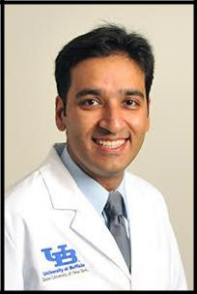

Ashish is a PGY-4 resident at the UB Neurology residency program. He was born in one of the most populous cities of the world, Delhi, India. He grew up in the sub-urbs of Delhi and went on to obtain his medical degree at Kasturba Medical College, Mangalore, India. He then moved on to a research fellowship in neu-

roimaging at Partners MS Center, Brigham & Women’s Hospital of Harvard Medi-

cal School in Boston, where his work included studying the correlation between data obtained from high resolution MRI scans of the brain and spinal cord with metrics of physical and cognitive disability in patients with MS. He has been a part of many national and international presentations, abstracts and peer-reviewed publications. He has won travel awards to the AAN as well as ECTRIMS/ ACTRIMS combined meetings.

Ashish started his internship at UB in 2013 and has been a neurology resident from 2014. He is one of the chief residents for the in-coming academic year. In his resi-dency training, other than the clinical training, he is involved with the PGY-3 class QI project that has been granted the GME QI award from the UB office of GME as well as clinical research involving the Kaleida Health stroke database.

He lives in Buffalo with his wife and daughter. He enjoys spending time with his family, swimming and exploring cuisines from different parts of the world. Upon completion of his residency, he’ll be moving to Texas for a Vascular Neurology Fellowship at The University of Texas in Houston, starting July of 2017.

20

Background:

The ECASS-III clinical trial showed that intravenous thrombolysis (IVT) improves functional outcome of acute ischemic stroke (AIS) in patients receiving IVT in a 3 to 4.5 hour period after symptom onset. It excluded patients >80 years, due to possible increase in risk of symptomatic intracranial hemorrhage (sICH). Most recent AHA/ASA guidelines on AIS treatment consider age >80 years a relative contraindication for IVT in the 3–4.5-hour window as little data exists on safety and efficacy.

Objective:

To assess the safety and efficacy of IVT for AIS in Patients older than 80 years of age within the 3–4.5-hour period after symptom onset.

Methods:

A retrospective medical record review was conducted of all pa-tients treated with IVT for AIS from 2006 to 2016. Comparisons were made in rates of sICH and poor outcome [modified Rankin Scale (mRS) of 3-6 on discharge, sICH defined as ICH with an increase in NIHSS of at least 4 points] in those >80 years receiving IVT within 3h vs. 3h-4.5h. We adjusted for other predictors of ICH and poor out-come including admission NIHSS, histories of diabetes, stroke and atrial fibrillation.

Results:

Total 834 patients received IVT for AIS during this period. 51 pa-tients (6.1 %) developed sICH. Total 296 patients were >80 years, of which 263 (88.8 %) were treated under 3h (<3h) and 36 (11.2%) were treated within 3h-4.5hours. No significant difference was ob-served in terms of age and other predictors. In multivariate analy-sis, sICH was lower in those receiving IVT < 3h compared to 3-4.5h, but it was not statistically significant.

Conclusions:

Although there was non-significant increase in rate of sICH in pa-tients older than 80 years, who received IVT within 3-4.5h from symptom onset, chance of poor outcome did not change signifi-cantly. Our result suggests that decision for IVT in the extended time window should not be solely based on patient's age.

IRB Approval:

Approved #MODCR00000144

Conflicts of Interest or Disclosures:

Nothing to declare relevant to the study. Please see page 26 for addi-tional disclosure information.

21

Identifying Predictors of Outcomes in NMOSD
Neuromyelitis Optica Spectrum Disorder

Svetlana P. Eckert, MD, Caila Vaughn, PhD, MPH, Aisha Bushra, MD, Bianca Weinstock-Guttman, MD

University at Buffalo; Department of Neurology Jacobs School of Medicine and Biomedical Science
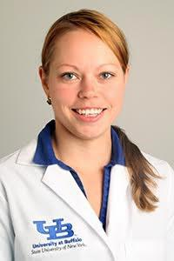

Svetlana Primma Eckert was born in Estonia, moved to the U.S. at the age of 14, after which she lived in Brooklyn, N.Y., Baltimore, M.D., and Washington, D.C. before moving to Buffalo for medical school and resi-dency. Her interest in neurology was inspired when she had to see a neurologist at a young age, and did not fade when she no longer need-ed to see one as a patient. At the Johns Hopkins University, she majored in Biophysics and worked in a molecular biology lab, but found her true passion while shadowing a Multiple Sclerosis (MS) specialist. After that, she briefly worked at the NIH as well, studying the effects of increasing sleep on obesity and weight loss.

She further pursued her interest in Multiple Sclerosis and Neuroimmunolo-gy in medical school through collecting data on pediatric MS disability and lipids and recently attended the Masters MS and the MS Fellowship Forum at the CMSC. Svetlana hopes to pursue a fellowship in MS and Neuroimaging and is currently focusing on a different autoimmune neu-rologic disease, Neuromyelitis Optica, in her resident research project. Besides her interest in neuroimmunology, Svetlana enjoys yoga, cycling - especially for the Ride for Roswell, and spending time with her pets: two crested geckos, two cats,and a golden retriever.

22

Background:

Neuromyelitis Optica Spectrum Disoder (NMOSD) is a type of autoim-mune demyelinating disease that can cause significant morbidity and mortality. To date, few studies have identified clinical factors predictive of higher morbidity of NMOSD that could potentially guide earlier and more aggressive disease modifying therapy initiation.

Objectives:

To determine whether demographic characteristics, various comorbidi-ties, or other concurrent autoimmune disorders and/or immunologic bi-omarkers can be identified as additional prognostic factors in NMOSD.

Methods:

We conducted a retrospective review of 240 patients with a diagnosis of optic neuritis(ON) and/or transverse myelitis(TM) from April 2012 through November 2016. 47 were identified to have NMOSD. 18 patients were excluded due to pediatric onset(n=5), lack of clinical information(n=10), or pregnancy(n=3). 29 were identified for the present study, 13/29(45%) were AQP-4 seropositive. Effects of demographics (age, gender) HTN, BMI, and presence of autoimmune antibodies on disease severity as evi-denced by Expanded Disability Status Scale (EDSS) on presentation and at 6-month follow-ups were analyzed. Immediate therapeutic interven-tions including oral vs. B-cell therapy following the diagnosis was includ-ed. Statistical analysis was performed using independent samples t-tests or chi-square tests to compare groups.

Results:

Patients with lower body mass index (BMI) had significantly higher EDSS scores on presentation in the AQP-4 negative group; AQP-4 antibody was an effect modifier. Patients with HTN showed less improvement of EDSS scores and ANA-positive patients had lower EDSS on presentation. Effect of ethnicity and antithyroid antibodies was unclear due to limited data. Anti-Hu, anti-Yo fluorescence positivity (negative western blot) was incidentally found in 4 patients. All were Caucasian, 2 AQP-4 positive, 3 with longitudinally extensive TM and 1 with brainstem involvement.

Conclusion: Patients with HTN, and AQP-4 negative patients with lower BMI on presentation had worse prognosis, consequently earlier initiation of higher efficacy immunosuppressive therapy in this group of NMOSD is warranted.

IRB Approval:

Study ID: 00000449

Conflict of Interest: Authors have no conflicts of interest to declare.

Disclosures: Resident has no disclosures to declare. Please see page 26 for Dr. Weinstock-Guttman’s disclosures.

23

Olfaction and Copy Number Variation in
Alzheimer’s Disease

Brian Trummer, MD, PhD
Kinga Szigeti, MD. PhD

University at Buffalo, Department of Neurology Jacobs School of Medicine and Biomedical Imaging
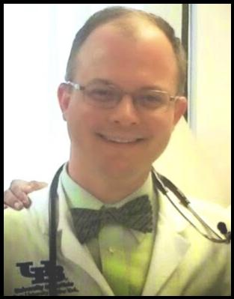

Years ago, while Buffalo, New York was hit by the blizzard of the century,
Brian was born in Queens, NYC. His childhood window overlooked the
Manhattan skyline, a constant inspiration as to what was capable by
the human mind. Brian set out to deepen his understanding of the uni-
verse at Cornell University, where he met his wife, Lynnette and studied
genetics and development. Later, he went off to the University of Ox-

ford, to undertake a Masters in genomic archaeology, where he studied
under his mentor, Professor Ryk Ward. On returning to New York City, he
worked at the Columbia University Genome Center for three years, de-
veloping carbohydrate microarray technology with Dr. Denong
Wang. Later, Brian worked briefly at Boehringer Ingelheim Pharmaceuti-
cals in the core lab for protein purification. His journey came full circle

when he began his MD/PhD program at Buffalo in 2004 and experiment-
ed with liposomal formulations of kinase inhibitors with mentor Dr.
Straubinger. He enjoyed the Buffalo lifestyle and was excited to contin-
ue on within the Neurology Residency program. Brian has 2 sons, Gabri-
el and Daniel who have been known to philosophize with faculty mem-

bers on diverse topics ranging from scorpions to the temporal discrep-
ancy between auditory and visual evoked potentials. Neither Brian
Trummer or any of his colleagues have any conflicts of interest or disclo-
sures to declare.

24

Background: Alzheimer’s disease is the most common form of

dementia, presenting a significant public health burden for soci-ety. Olfactory testing could offer early identification of patients at risk.

Objectives: Identification of 10/40 odors that best distinguish Alz-heimer’s disease patients from normal controls and determine if they share a common chemical structure. Analyzing copy num-ber variation in the olfactory genome of Alzheimer’s patients and normal age matched controls to see if there were a difference in genomic gain/loss events.

Methods: 841 participants underwent neuropsychiatric testing (classified into 234 normal controls, 192 amnestic mild cognitive impairment, and 415 Alzheimer’s patients) and participated in the University of Pennsylvania Smell Identification Test (UPSIT) of
- odors. AD-associated smells (AD-10) were selected based on a model of ordinal logistic regression. Microarray analysis of copy number variants around the olfactory genome and chi square testing of loss and gain events in copy number variants was conducted.

Results: The 10 identifiable odors that distinguish Alzheimer’s dis-

ease are: watermelon, soap, rose, fruit punch, turpentine, pine, dill pickle, strawberry, grape, and wintergreen. We found no shared compound structure. While copy number variation gain and loss events between Alzheimer’s & aMCI patients vs normal controls was not significant with a p value of 0.808462; we found statistical significance in more genomic loss events / fewer ge-nomic gain events in the oldest quartile tested compared to the youngest age quartile with a p value of 0.000428.

Conclusions: We have identified a subset of 10 distinct odors to distinguish Alzheimer’s patients from normal controls. While Alz-heimer’s disease and normal controls are similar in CNV frequen-cy, we discovered older individuals have a statistically significant increase in genomic loss events / fewer genomic gain events than a younger population.

IRB Approval:

Approved, NEU3081010A

Conflict of Interest: Authors have no conflicts of interest to declare.

Disclosures: Neither Resident nor Mentor have anything to disclose.

25

Disclosures:

Ashkan Mowla, MD -

Member, Steering committee for Medtronic Diagnostics for FDA ap-proved indications for Reveal LINQ ICM. Dr. Mowla is a member, Johnson
- Johnson pharmaceuticals,Inc. speaker bureau and advisory board. He also serves as the site-PI on industry funded research projects NAVI-GATE ESUS and STROKE-AF.

Bianca Weinstock-Guttman, MD -

Bianca Weinstock- Guttman received honoraria as a speaker and as a consultant for Biogen Idec,Teva Pharmaceuticals, EMD Serono, Gen-zyme, Sanofi, Novartis and Acorda. Dr Weinstock-Guttman received re-search funds from Biogen Idec, Teva Pharmaceuticals, EMD Serono, Genzyme, Sanofi, Novartis, Acorda.

No additional disclosures.

26

NOTES: _______________________

_______________________________

_______________________________

_______________________________

_______________________________

_______________________________

_______________________________

_______________________________

_______________________________

_______________________________

_______________________________

_______________________________

_______________________________

_______________________________

_______________________________

_______________________________

_______________________________

This program was produced with the support of:
The Buffalo Neuroimaging Analysis Center (BNAC).

27

Graduation Dinner:

The Hotel Lafayette-The Courtyard Room
391 Washington Street

Buffalo, NY 14203
June 9, 2017

6:00 pm

Cocktails

7:00 pm

Dinner

Adult Neurology Resident Program
Director’s Introductions and Comments:

Nicholas J. Silvestri, MD

Chairman’s Address:

Gil I. Wolfe, MD, FAAN

Neurology Resident Research Program Director’s

Comments:

Robert Zivadinov, MD, PhD, FAAN, FANA, FEAN

Michael E. Cohen Research Day Awards
Presentation:

Michael E. Cohen, MD

Graduation Ceremony for Graduating Residents &

Fellows:

Nicholas J. Silvestri, MD, Adult Neurology Resident

Program Director;
Sarah Finnegan, MD, PhD, Child Neurology Resident

Program Director;
Ping Li, MD; Clinical Neurophysiology Fellowship

Program Director;
Margaret Paroski, MD, Director, Neurology Clerkship

Message from Outgoing Chief Residents:

Ashish Arora, MBBS & Svetlana Eckert, MD

Message by In-coming Chief Resident:

Sandhya Mehla, MBBS

9:30 p.m. - End of Reception

28

