University at Buffalo Department of Orthopaedics
RESEARCH NEWSLETTER

Department Chair: Leslie J. Bisson, MD

Director of Clinical Research: John Leddy, MD

Director, Kenneth A Krackow Orthopedic Research Lab: Mark Ehrensberger, PhD

Editors: Allison Cornwall, MPH; Melissa Kluczynski, MS; Sonja Pavlesen, MD, MS

Introduction from the Chair

It gives me great pleasure to introduce the first volume of the Orthopaedic Depart-ment's quarterly research newsletter. Our department is undergoing exciting transformations, and many of them are happening in research. We have long had a well-organized approach to basic science and biomechanics under the direction of Mark Ehrensberger, PhD and a focus on concussion research led by John Led-dy, MD as well as Barry Willer, PhD from the Department of Psychiatry. To this we have been adding and organizing the assets needed for a robust clinical re-search program, which now include the following personnel: John Leddy MD, Di-rector of Clinical Research; Terry Mashtare PhD, Biostatistician; Melissa Kluczyn-ski, MS, Clinical Research Associate (CRA) for Sports Medicine; Allison Cornwall, MPH, CRA for ECMC; Sonja Pavlesen, MD, MS, CRA for Buffalo General Hospi-tal; and Mary Bayers-Thering, who in addition to serving as a Research Coordina-tor at BGH will also act as Coordinator for Surgical Skills Training.

The focus of clinical research will be to carry out high-impact investigations in musculoskeletal medicine, prioritizing collaborations between multiple investiga-tors, those which have high potential for intra- and extramural funding, and those which include investigators outside Orthopaedics. We have established a fracture registry at ECMC which records and classifies all major fractures treated there, facilitating improvements in trauma care. This registry has already collected data on over 1100 fractures. We have made a significant investment in a software pro-gram to measure patient outcomes, Oberd, which will be routinely used by UBMD Orthopaedics & Sports Medicine to continuously improve patient care. In addition to its substantial clinical utility, Oberd will facilitate outcome studies, helping us to accurately identify how and where treatments differ. Finally, we are entering into a productive collaboration with Carestream Health Inc., which will involve multiple investigations at ECMC using their cone beam 3D CT scanner. These are just a few of the exciting new events, and there are more to come! Please join me in welcoming our new people in research, please help them make our department successful, and please thank them for their work.

Leslie J. Bisson, M.D.

June A. and Eugene R. Mindell, MD Professor and Chair

Announcements

Thank you to everyone who attended the Good Research Practices (GRP) Training sessions! Handouts from the sessions can be accessed online: www.research.buffalo.edu/rsp/training

GRP training is mandatory for all personnel engaged in research. If you still need to complete this training, please sign up online: www.research.buffalo.edu/rsp/training/

Volume 1; March 2015
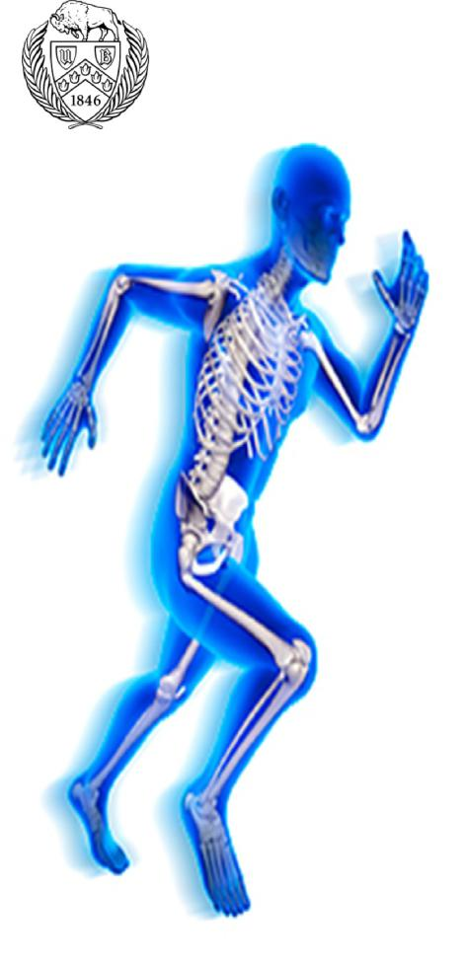

Inside this issue

Introduction from the Chair 1

Announcements 1

Recent Presentations 2

Recent Publications 2-3

Clinical Studies, Recently Funded

& New Studies 3

Sponsored Basic Science Studies

3

What is the S Drive? 4

Research Funding Sources/Grant

Deadlines 4

Upcoming Abstract Deadlines 4

Steps to a Clinical Research

Study 5

Biomechanics Update 6

Research Team Contact Info . 6

Recent Publications

Recent Presentations

Leddy, J.J. The Physiolo-gy of Concussion: Impli-

cations for Diagnosis, Prognosis and Treatment. Brain Injury Summit: a Meeting of the Minds, Craig Hospital, Vail, Colo-rado. January 2015.

Peer-Reviewed Journal Articles

Ablove T, Binkley N, Leadley S, Shelton J, Ablove RH. Body Mass Index Accurately Predicts Body Fat Percentage in Aging Women. Menopause, In Press.

Ablove, R.H., Abrams, S. (2015). The Use of BMP-2 and Screw Exchange in the Treatment of Scaphoid Fracture Non-union. Journal of Hand Surgery (Asian Volume), 20(1): 167-171.

Baker JG, Leddy JJ, Darling SR, Rieger BP, Mashtare TL, Sharma T and Willer B. Factors Associ-ated with Problems for Adolescents Returning to the Classroom after Sport-Related Concussion. Clinical Pediatrics, In Press.

Brown, M., Pula, D., Kluczynski, M.A., Mashtare, T.L., Bisson, L.J. Does suture technique affect re -rupture after arthroscopic rotator cuff repair?: A meta-analysis. Arthroscopy, In Press.

Doak J, J Schiller, C Eberson. "Circulation of the Pediatric and Adolescent Hip. In: Skeletal Circu-lation in Clinical Practice" Ed. Roy K. Aaron. World Scientific Singapore, In Press.

Ehrensberger MT, Tobias ME, Nodzo SR, Hansen LA, Luke-Marshall NR, Cole RF, Wild LM, Campagnari AA. Cathodic Voltage-Controlled Electrical Stimulation of Titanium Implants as Treat-ment for Methicillin-Resistant Staphylococcus aureus Periprosthetic Infections. Biomaterials. In Press.

Ellis M, Leddy JJ and Willer B. Evaluation and Treatment of Physiologic, Vestibulo-Ocular, and Cervicogenic Post-Concussion Disorders. Brain Injury, In Press.

Hohman DW, Nodzo SR, Phillips M, Fitz W. The Implications of Mechanical Alignment on Soft Tissue Balancing in Total Knee Arthroplasty. Knee Surgery, Sports, Traumatology, Arthroscopy, In Press.

Krackow, KA, Puttaswamy, MK, Raju, S: Medial over resection of the tibia in TKA for varus de-formity using computer navigation. The Journal of Arthroplasty, In Press.

Kluczynski, M.A., Isenburg, M., Marzo, J.M., Bisson, L.J. Does Early versus Delayed Active Range of Motion Affect Rotator Cuff Healing Following Surgical Repair?: A Systematic Review and Meta-analysis. American Journal of Sports Medicine, In Press.

Kluczynski, M.A., Nayyar, S., Marzo, J.M., Bisson, L.J. Early versus Delayed Passive Range of Motion Following Rotator Cuff Repair: A Meta-analysis. American Journal of Sports Medicine, In Press.

Kluczynski, M.A., Marzo, J.M., Rauh, M.A., Bernas, G.A., Bisson, L.J. Sex-specific Predictors of Intra-articular Injuries Observed during Anterior Cruciate Ligament Reconstruction. Orthopaedic

Journal of Sports Medicine, In Press.

Leddy, J.J., Baker, J.G., Merchant, A., Picano, J., Gaile, D., Matuszak, J., Willer, B. Brain or Strain? Symptoms alone do not distinguish physiologic concussion from cervical/vestibular injury. Clinical Journal of Sports Medicine, In Press.

Matava MJ, Arciero RA, Baumgarten KM, Carey JL, DeBerardino TM, Hame SL, Hannafin JA, Miller BS, Nissen CW, Taft TN, Wolf BR, Wright RW; MARS Group. (2015) Multirater agreement of the causes of anterior cruciate ligament reconstruction failure: a radiographic and video analysis of the Mars cohort. Am J Sports, 43(2):310-9.

Nodzo SR, Bauer T, Pottinger P, Garrigues G, Bedair H, Deirmengian C, Segreti J, Blount KJ, Omar IM, Parvizi J. Conventional Diagnostic Challeng-es in Periprosthetic Infection. Journal of the American Academy of Orthopaedic Surgeons. In Press.

Nodzo SR, Hohman DW, Chakravarthy K. Nanotechnology: Should We Care?. The American Journal of Orthopedics. In Press.

Polak, P., Leddy, J.J., Dwyer, M.G., Willer, B., Zivadinov, R. Diffusion Tensor Imaging Alterations in Post-Concussion Syndrome Patients Undergoing Exercise Treatment: A Pilot Longitudinal Study. The Journal of Head Trauma Rehabilitation, In Press.

AM Smith, MJ Stuart, DW Dodick, WO Roberts, PW Alford, AB Ashare, M Aubrey, BW Benson, CJ Burke, R Dick, C Eickhoff, CA Emery, LA Flash-man, D Gaz, CC Giza, RM Greenwald, S Herring, TB Hoshizaki, JJ Hudziak, J Huston III, D Krause, N LaVoi, M Leaf, JJ Leddy, A MacPherson, AC McKee, JP Mihalik, AM Moessner, WJ Montelpare, M Putukian, KJ Schneider, R Szalkowski, M Tabrum, J Whitehead, and DM Wiese-Bjornstal. Ice Hockey Summit II: Zero Tolerance for Head Hits and Fighting. Clinical Journal of Sports Medicine, and Physical Medicine & Rehabilitation, In press.

2

Recent Publications (continued)

Book Chapters

Ablove RH, Ligamentous Reconstruction of the Elbow, American Society for Surgery of the Hand, Resident e-Book. In Press.

Ablove RH. Hand Extensors. In Chapman’s Comprehensive Orthopaedic Surgery, Fourth Edition, James M, Chapman MW (ed). In Press.

Bryan T, Duquin TR. Distal Humerus Nonunions / Malunions. Elbow Trauma: A Master Skills Publication. In Press.

Duquin TR, Steinmann S. Osteotomy for distal humeral malunion. Masters Techniques in Orthopaedic Surgery: The Elbow 3rd edition. Wolters Kluwer. 2015. Ch 11:147-156.

Duquin TR, Sperling JW. Complication management malunion and nonunion of proximal humerus fractures. Art of Proximal Humerus Fractures. Springer-Verlag. In press.

Duquin TR, Sperling JW. RSA for revision of failed RSA and technique for removal of previous components. Reverse Shoulder Arthroplasty: Clinical Techniques and Devices. In press.

Duquin TR, Sperling JW. Inflammatory arthropathies of the shoulder. Clinical Decision Support: Shoulder and Elbow. In press.

Duquin TR. Complex elbow dislocation. Clinical Decision Support: Shoulder and Elbow.
In press.

Duquin TR, Sperling JW. Revision Shoulder Arthroplasty for Wear or Loosening. Ad-vanced Reconstruction: Shoulder 2. In press.

Urband C, Duquin TR. Sternoclavicular Joint Injury. Shoulder and Elbow Trauma and its Complications I: The Shoulder. In Press.

Sponsored Basic Science Studies

Study Title: The mechanical advantage of using a fully threaded postero -superior screw as part of the inverted triangle cannulated screw configuration when fixing intra-capsular femoral neck fractures associated with posterior comminution in osteoporotic bone. Investigators: Rachala, SR. Kuechle, J., Kakish, S.; Sponsor: Zimmer.

Study Title: Reverse Total Shoulder Baseplate Fixation with Bone Loss. Investiga-

tors: Ehrensberger MT and Duquin T. Sponsor: Biomet Inc.

Study Title: Biomechanical Analysis of Standard and Minimally Invasive Acetabular

Reamers. Investigators: Ehrensberger MT Sponsors: Greatbatch Medical, Symmetry Medical, Zimmer.

Study Title: Electrical Stimulation of Titanium for the Prevention and/or Eradication of A. baumannii and S. aureus Biofilm Infections on Osseointegrated Prostheses. Investi-gators: Ehrensberger MT, Campagnari AA, Gill SR, Luke NR, Russo TA, Takeuchi E. Sponsor: Congressionally Directed Medical Research Program- Peer Reviewed Ortho-pedic Research Program, Idea Development Grant.

Study Title: Rocking Horse Testing of Glenoid Components in Total Shoulder Ar-
throplasty. Investigators: Ehrensberger MT. Sponsor: Excelsior Foundation.

Study Title: Testing and Development of Orthopedic Proprietary Products. Investi-

gators: Ehrensberger MT. Sponsor: Greatbatch Medical and UB Center for Ad-vanced Biomedical and Bioengineering Technology.

Study Title: A Novel Electrical Stimulation Method for the Eradication/Preventions

of Orthopedic Biofilms. Investigators: Ehrensberger MT and Campagnari AA. Sponsor:

Bruce Holm Memorial Catalyst Fund.

Study Title: Novel Biomechanical Analysis of Hamstring Graft Fixation with Inter-

ference Screw. Investigators: Ehrensberger MT. Sponsor: Arthrex, Inc.

Clinical Studies, Recently Funded & New Studies

Study Title: ‘Comparison of a novel weight bearing cone beam computed tomography (CT) scanner versus a con-ventional CT scanner for measuring patellar instability;’ Investigators: Drs. Marzo, Bernas, Bisson, Fineberg, Notino, Rauh, & Wind; Spon-sor: Carestream Health, Inc.

Study Title: ‘Hip fracture evaluation with alternatives of total hip arthroplasty versus hemi-arthroplasty (HEALTH);’ Investigators: Anders, M., Mutty, C. Phillips, MJ., Racha-la, SR. Sponsor: NIH.

Study Title: ‘Frailty, sarco-penia and outcomes in ortho-paedic trauma patients;’ Investigators: Touban, B., Anders, M., Mutty, C. Funding Source: Orthopaedic Trau-ma Association.

Study Title: ‘A prospective, randomized controlled trial evaluating regional liposomal bupivacaine versus ropiva-caine on post-operative pain management after primary hallux valgus correction;’ In-vestigators: Boyle, K., Rit-ter, C., Rohrbacher, B. Fund-ing Source: Department of Orthopaedics.

Study Title: ‘Post Market Study of the Stryker Ortho-paedics Triathlon® PKR Knee System;’ Investigators: Phil-lips, MJ., Rachala, SR., ; Sponsor: Stryker.

Study Title: ‘Synovasure: New Synovial Fluid Diagnostic Test for Infection;’ Investiga-tors: Krackow, KA., Phillips, MJ., Rachala, SR; Sponsor: Citrano Laboratories, Inc.

Study Title: ‘Minimum 2 Year Follow Up of a Hydroxy-apatite Coated Metal Backed Patella;’ Investigators: Nodzo, S., Phillips, MJ. Sponsor: Stryker.

3

What is the S Drive?

Research Funding Sources/Grant Deadlines

Password protected file storage space for the Dept. of Orthopaedics

What are some things that are stored on the Or-tho S Drive?

- A list of specialty asso-ciations, meeting dates, funding deadlines

- Steps for clinical re-search projects

- Current research pro-jects and ideas

- Resident research pro-posals

- Templates (Pre-study abstract, Dept. Power-Point, etc.)

- Research staff contact info

How do you access the S Drive?
S:\ORT\Research

- Citrix: http:// www.smbs.buffalo.edu/ omc/

compu-
ting_application.htm

- Cloud: https:// cloudmed.med.buffalo. edu/htcomnet
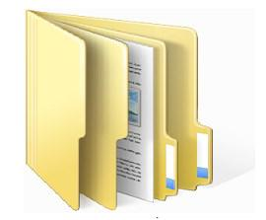

The Knee Society Research Grant Program

Funds: $15,000/1 yr. basic science; $45,000/2yrs clini-cal study award

Eligibility: PI or C0-PI must be member of The Knee Society

Deadline: open

Web-link: http:// www.kneesociety.org/web/ research.htm

The American Foot & Ankle Society (AOFAS)

Funds: $20,000/1 yr. Re-search grant; $5,000/1 yr. Pilot project grant

Eligibility: Research grant (PI or C0-PI must be AO-FAS active member, candi-date member, or interna-tional member; Pilot project grant (applicants must be resident or fellow AOFAS member, and an AOFAS

active member, candidate member, or international member must serve as ei-ther study PI, CO-PI, or pro-ject advisor)

Deadline: December 1, 2015 (application material August 2015)

Web-link: http://

www.aofas.org/medical-community/Pages/Research-Grants.aspx
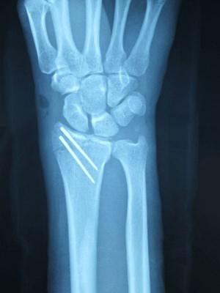

Upcoming Abstract Deadlines

American Orthopaedic Society for Sports Medicine (AOSSM)/ Specialty Day, Abstracts accepted from mid-March through May 12, 2015

American Academy of Orthopaedic Surgeons (AAOS), Abstracts due June 1, 2015

4

Steps to a Clinical Research Project
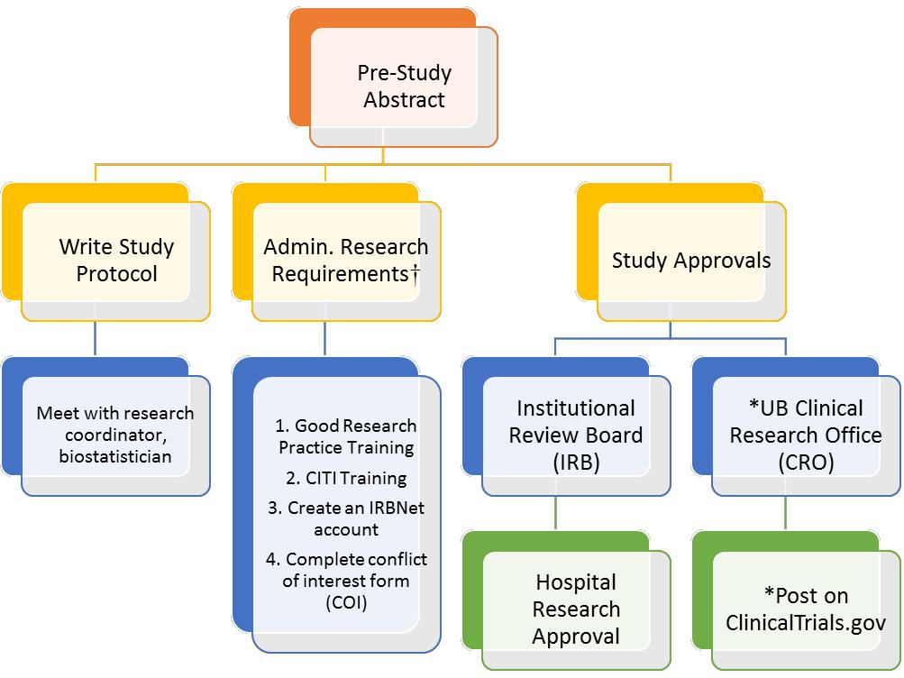

†Required for all study investigators and staff engaged in research.
*only applies to prospective research

This flow chart shows the start-up steps for conducting clinical research. Please seek assistance from a study coordinator for any/all steps of this process. Our dept. asks that all IRB and hospital applications are approved by a research coordinator before submission.

The template for the pre-study abstract is located in the research folder on the department S drive. When completed, you can submit to any member of the clinical research staff. It will be reviewed, you will receive comments within 2 weeks.

When the pre-study abstract is approved, begin writing the study protocol. The appropriate template is also located on the S drive labeled “HRP-503 TEMPLATE PROTOCOL.” Please seek the assistance of a re-search coordinator for help with study design and the dept. biostatistician for a power analysis and data col-lection set up.

5

Biomechanics Update
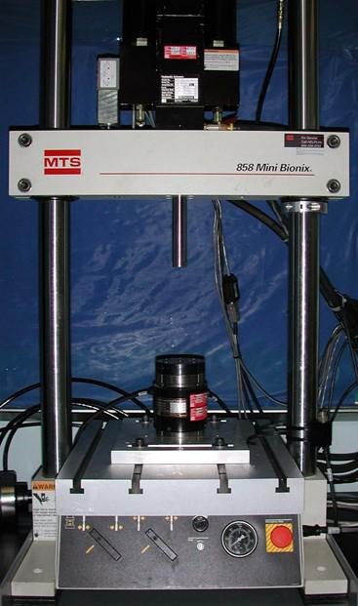

What is the MTS Machine?

The laboratory maintains an MTS 858 Mini Bionix servo-hydraulic load frame that provides a versatile platform for me-chanical testing of orthopaedic specimens and materials. The performance specifications of this system enable axial testing (compression/tension) in load-controlled (0-10kN) or displace-ment-controlled (+/- 60mm) conditions, as well as torsional test-ing in torque-controlled (+/- 100N-m) or rotation-controlled (+/-140 deg) conditions. The typical test configuration includes a load/torque sensor that is rigidly secured to the stationary baseplate of the load frame. The load/torque sensors available in the lab include 100N, 2500N, and 10,000N sensors. The actuator piston is mounted within the height adjustable load frame crossbeam. A variety of test fixtures (grips, vises, custom jigs, etc.) can then be connected to the ends of the actuator and load sensor to enable the secure mounting of specimens for mechanical testing. Specialty test fixtures available include the MTS three- and four-point bending test stages and the Bose thermal-electrically cooled soft tissue grips. More infor-mation can be found at www.mts.com.

Research Team Contact Information

John Leddy MD leddy@buffalo.edu, Director of Clinical Research

Mark Ehrensberger, PhD mte@buffalo.edu, Director, Kenneth A Krackow Orthopedic Research Lab

Terry Mashtare, PhD tlm24@buffalo.edu, Biostatistician

Buffalo General Hospital

Sonja Pavlesen, MD, MS pavlesen@buffalo.edu, Clinical Research Associate

Mary Bayers-Thering, MS, MBA MBayers-Thering@KaleidaHealth.Org, Research Coordinator, Coordinator for Surgical Skills Training

Erie County Medical Center

Allison Cornwall, MPH aec23@buffalo.edu, Clinical Research Associate

Sports Medicine/Harlem Rd. office

Melissa Kluczynski, MS mk67@buffalo.edu, Clinical Research Associate

Please send research news items for future issues of this newsletter to Allison Cornwall.
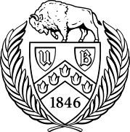

University at Buffalo Department of Orthopaedics Research Newsletter

6

Orthopaedic and Sports Medicine Research Funding Sources (non-profit, government, academic and industry)

Organization/Institution |  |  | Direct web-link |  |  |  |  |  |  |  |  | Deadlines
OREF (Orthopaedic Research and |  | http://www.oref.org/site/PageServer?pagename=OREF_Grants_and_Awards |  |  |  |  |  |  |  |  |  | Various, 2015
 |  |  |  |  |  |  |  |  |  |  |  | deadlines not
Education Foundation)
 |  |  |  |  |  |  |  |  |  |  |  | announced yet
ORS (Orthopaedic Research Society) |  | http://www.ors.org/awards-grants-funding/ |  |  |  |  |  |  |  |  |  | Various
AOSSM (The American Orthopaedic Society |  | http://www.sportsmed.org/Research/Research_Grants/Grants/ |  |  |  |  |  |  |  |  |  | Various, 2015
for Sports Medicine) |  |  |  |  |  |  |  |  |  |  |  | deadlines not
 |  |  |  |  |  |  |  |  |  |  |  | announced yet
AMSSM (American Medical Society for |  | http://www.amssm.org/Research.html |  |  |  |  |  |  |  |  |  | Various, 2015
Sports Medicine) |  |  |  |  |  |  |  |  |  |  |  | deadlines not
 |  |  |  |  |  |  |  |  |  |  |  | announced yet
ACSM (American College of Sports |  | http://www.acsm.org/find-continuing-education/awards-grants/research-grants |  |  |  |  |  |  |  |  |  | January 2016
Medicine)
OTA (Orthopaedic Trauma Association) |  | http://ota.org/research/research-studies/ |  |  |  |  |  |  |  |  |  | Research &
 |  |  |  |  |  |  |  |  |  |  |  | Resident
 |  |  |  |  |  |  |  |  |  |  |  | Grants- June
 |  |  |  |  |  |  |  |  |  |  |  | 2015
AO Foundation (Trauma) |  | https://www.aofoundation.org/Structure/research/research-funding/Pages/Start- |  |  |  |  |  |  |  |  |  | July 2015
 |  | up-grants.aspx
AANA (Arthroscopy Association of North |  | https://www.aana.org/ResearchAwardsGrants/tabid/60/Default.aspx |  |  |  |  |  |  |  |  |  | November 2015
America)

1

ASBMR (American Society for Bone and |  | http://www.asbmr.org/Grants/Default.aspx |  |  |  |  |  |  |  |  |  |  |  |  | Various, April
Mineral Research) |  |  |  |  |  |  |  |  |  |  |  |  |  |  | 2015
AFAR (American Federation for Aging |  | http://www.afar.org/research/funding/ |  |  |  |  |  |  |  |  |  |  |  |  | Various, 2015
Research) |  |  |  |  |  |  |  |  |  |  |  |  |  |  | deadlines not
 |  |  |  |  |  |  |  |  |  |  |  |  |  |  | announced yet
The Knee Society |  | http://www.kneesociety.org/web/research.html |  |  |  |  |  |  |  |  |  |  |  |  | Open
Arthritis Foundation |  | http://www.arthritis.org/research/funding-opportunities/ |  |  |  |  |  |  |  |  |  |  |  |  | 2015 deadlines
 |  |  |  |  |  |  |  |  |  |  |  |  |  |  | not announced
 |  |  |  |  |  |  |  |  |  |  |  |  |  |  | yet
ASES (American Shoulder and Elbow |  | http://www.ases-assn.org/?p=physic-grants |  |  |  |  |  |  |  |  |  |  |  |  | September
Surgeons) |  |  |  |  |  |  |  |  |  |  |  |  |  |  | 2015
ASSH (American Society for Surgery of the |  | http://www.assh.org/Member-Resources/Grants-and-Awards |  |  |  |  |  |  |  |  |  |  |  |  | April 5, 2015
Hand)
NASS (North America Spine Society) |  | https://www.spine.org/Pages/ResearchClinicalCare/FundMyResearch/FundingOppo |  |  |  |  |  |  |  |  |  |  |  |  | May 4, 2015 (by
 |  | rtunities.aspx |  |  |  |  |  |  |  |  |  |  |  |  | invitation only)
AOFAS (American Foot & Ankle Society) |  | http://www.aofas.org/medical-community/Pages/Research-Grants.aspx |  |  |  |  |  |  |  |  |  |  |  |  | 2015 deadlines
 |  |  |  |  |  |  |  |  |  |  |  |  |  |  | not announced
 |  |  |  |  |  |  |  |  |  |  |  |  |  |  | yet
The Pediatric Orthopaedic Society of North |  | http://www.posna.org/research/research.asp |  |  |  |  |  |  |  |  |  |  |  |  | 2015 deadlines
America |  |  |  |  |  |  |  |  |  |  |  |  |  |  | not announced
 |  |  |  |  |  |  |  |  |  |  |  |  |  |  | yet
NIAMS (National Institute of Arthritis and |  | http://www.niams.nih.gov/Funding/Funding_Opportunities/ |  |  |  |  |  |  |  |  |  |  |  |  | Various,
Musculoskeletal and Skin Diseases) |  |  |  |  |  |  |  |  |  |  |  |  |  |  | ongoing
NIDDR (National Institute of Disability and |  | http://www2.ed.gov/programs/nidrr/fy15nidrrandaclgrantcompetitions.html |  |  |  |  |  |  |  |  |  |  |  |  | Various
Rehabilitation Research)

2

CDMRP/DOD (Congressionally Directed |  | http://cdmrp.army.mil/funding/default.shtml |  |  |  |  |  |  |  |  |  |  |  |  |  | Various
Medical Research Program/ Department of
Defense)
PCORI (Patient Centered Outcome |  | http://www.pcori.org/funding/opportunities |  |  |  |  |  |  |  |  |  |  |  |  |  | April-May 2015
Research Opportunities)
UB IMPACT (Innovative Micro_Programs |  | http://www.research.buffalo.edu/funding_programs/impact.cfm |  |  |  |  |  |  |  |  |  |  |  |  |  | March 2, 2015
Accelerating Collaboration in Themes)
UB CTR (Clinical and Translational Research |  | http://www.research.buffalo.edu/funding_programs/translational.cfm |  |  |  |  |  |  |  |  |  |  |  |  |  | April 3, 2015
Center/ Translational Pilot Study Fund)
UB Medical Education Program |  | http://medicine.buffalo.edu/education/md/about-the-program/financial- |  |  |  |  |  |  |  |  |  |  |  |  |  | Various
 |  | assistance/scholarships.html
The John R. Oishei Foundation |  | http://www.oishei.org/index.php/apply |  |  |  |  |  |  |  |  |  |  |  |  |  | Open
(Buffalo NY)
Patrick P. Lee Foundation |  | http://www.patrickpleefoundation.org/types/medical-care-research/ |  |  |  |  |  |  |  |  |  |  |  |  |  | 2015 deadlines
 |  |  |  |  |  |  |  |  |  |  |  |  |  |  |  | not announced
 |  |  |  |  |  |  |  |  |  |  |  |  |  |  |  | yet
NFL (National Football League Foundation) |  | http://www.nflfoundation.org/#grants |  |  |  |  |  |  |  |  |  |  |  |  |  | 2015 deadlines
 |  |  |  |  |  |  |  |  |  |  |  |  |  |  |  | not announced
 |  |  |  |  |  |  |  |  |  |  |  |  |  |  |  | yet
NCAA (National College Athletic |  | http://www.ncaa.org/about/resources/research/ncaa-innovations-research-and- |  |  |  |  |  |  |  |  |  |  |  |  |  | December 2015
Association) |  | practice-grant-program
Buffalo Sabres Foundation |  | http://sabres.nhl.com/club/page.htm?id=89108 |  |  |  |  |  |  |  |  |  |  |  |  |  | January 2016
OMeGA (Medical Grants Association) |  | http://www.omegamedicalgrants.org |  |  |  |  |  |  |  |  |  |  |  |  |  | March 2015

3

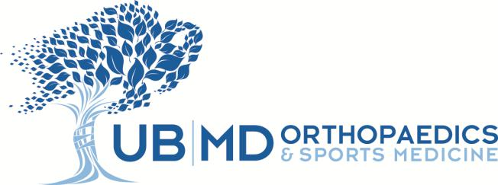

List of 2014 Publications and Presentations

PUBLICATIONS

Ablove, R.H., Aul, A., Baer, G. (2014). The Incidence and Demographics of Shoulder Repair in Wisconsin, 2002–2010.
Wisconsin Medical Journal, 113(6): 223-226.

Antonius, D., Matthew, N., Picano, J., Cogswell, A., Olympia, J., Brooks, T., DiGiacomo, M., Baker, J.G., Willer, B., and Leddy, J.J. (2014). Behavioral Health Symptoms Associated with Chronic Traumatic Encephalopathy: A Critical Review of the Literature and Recommendations for Treatment and Research. The Journal of Neuropsychiatry and Clinical Neurosciences, 26(4):313–322.

Baghdadi YM, Jacobson JA, DuquinTR, Larson DR, Morrey BF, Sanchez-Sotelo J. (2014). The outcome of total elbow arthroplasty in juvenile idiopathic arthritis (juvenile rheumatoid arthritis) patients. Journal of Shoulder Elbow and Surgery, 23(9):1374-1380.

Bar-Or D, Salottolo K, Loose H, Phillips M, McGrath B, Wei N, Borders J, Ervin J, Kivitz A, Hermann M, Shlotzhauer T, Churchill M, Slappey D, Clift V. (2014). A randomized clinical trial to evaluate two doses of an intra-articular injection of LMWF-5A in adults with pain due to osteoarthritis of the knee. PLOS ONE, 9(2): e87910.

Bisson, L.J., Komm, J.T., Bernas, G.A., Fineberg, M.S., Marzo, J.M., Rauh, M.A., Smolinski, R.J., Wind, W.M. (2014). Accuracy of a Computer-based Diagnostic Program for Ambulatory Patients with Knee Pain. American Journal of Sports Medicine, 42(10): 2371-2376.

Brooks, E., Tobias, M., Krautsak, K., Ehrensberger, M. (2014). The Influence of Cathodic Polarization and Simulated Inflammation on Titanium Electrochemistry. Journal of Biomedical Materials Research Part B: Applied Biomaterials, 102(7): 1445-1453.

Cannon, W.D., Garrett, W.E. Jr., Hunter, R.E., Sweeney, H.J., Eckhoff, D.G., Nicandri, G.T., Hutchinson, M.R., Johnson, D.D., Bisson, L.J., Bedi, A., Hill, J.A., Koh, J.L., Reinig, K.D. (2014). Improving Residency Training in Arthroscopic Knee Surgery with Use of a Virtual-Reality Simulator: A Randomized Blinded Study. Journal of Bone and Joint Surgery America, 96(21): 1798-1806.

Darling, S.R., Leddy, J.J., Baker, J.G., Williams, A.J., Surace, A., Miecznikowski, J.C., and Willer, B. (2014). Evaluation of the Zurich Guidelines and Exercise Testing for Return to Play in Adolescents Following Concussion. Clinical Journal of Sports Medicine, 24(2):128–133.

Duquin TR, Jacobson JA, Schleck CD, Larson DR, Sanchez-Sotelo J, Morrey BF. (2014) Triceps insufficiency after the treatment of deep infection following total elbow replacement. Bone Joint, 96(1):82-87.

Dyskin, E., Marzo, J.M., Howard, C., Ehrensberger, M. (2014) A Biomechanical Analysis of a Single-Row Suture Anchor Fixation of a Large Bony Bankart Lesion. Arthroscopy, 30(12): 1562-1568.

1

Ehrensberger MT, Tobias ME, Nodzo SR, Hansen LA, Luke-Marshall NR, Cole RF, Wild LM, Campagnari AA. (2014). Cathodic Voltage-Controlled Electrical Stimulation of Titanium Implants as Treatment for Methicillin-Resistant Staphylococcus aureus Periprosthetic Infections. Biomaterials, 41: 97-105.

Herman, A.M., Marzo, J.M. (2014). Popliteal cysts: A Current Review. Orthopedics, 37(8): e678-684.

Hohman, D.W., Nodzo, S.R., Qvick, L.M., Duquin, T.R., Paterson P.P. (2014). Hemiarthroplasty of the distal humerus for acute and chronic complex intra-articular injuries. Journal of Shoulder and Elbow Surgery, 23(2):265-272.

Jacobson JA, Duquin TR, Sanchez-Sotelo J, Schleck CD, Sperling JW, Cofield RH. (2014). Anatomic shoulder arthroplasty for treatment of proximal humerus malunions. Journal of Shoulder and Elbow Surgery, 23(8):1232-1239.

Kluczynski, M.A., Bisson, L.J., Marzo, J.M. (2014). Does Body Mass Index Affect Outcomes Following Ambulatory Knee and Shoulder Surgery? Arthroscopy, 30(7), 856-865.

Lavernia, C.J., Rodriquez, J.A., Hungerford, D.S., Krackow, K.A. (2014). Bone mineral density of the femur in autopsy retrieved total knee arthroplasties. Journal of Arthroplasty, 29(8): 1681-1686.

Loomans, R., Grogan, B., Kliowski, R., Ablove, R.H. (2014). The capsular attachment of the ulnar cornoid process: an MRI arthrography study. Current Orthopaedic Practice, 25 (1):34-36.

MARS Group. (2014). Effect of Graft Choice on the Outcome of Revision Anterior Cruciate Ligament Reconstruction in the Multicenter ACL Revision Study (MARS) Cohort. American Journal of Sports Medicine, 42(10): 2301-2310.

MARS Group. (2014). Osteoarthritis Classification Scales: Interobserver Reliability and Arthroscopic Correlation. Journal
of Bone and Joint Surgery America, 96(14): 1145-1151.

McGrath, B., Kuechle, JB. (2014). Hip Arthroscopic Portal Bridge Retraction Technique for Improved Peripheral Compartment Visualization. Arthroscopy Techniques, 3(4): e501-503.

Nodzo, S.R., Miladore, M.P., Kaplan, N.B., Ritter, C.A. (2014). Short to Midterm Clinical and Radiographic Outcomes of the Total Ankle Prosthesis. Foot and Ankle International, 35(1):22-29.

Nodzo, S.R., Hohman, D.W., Crane, J., Duquin, T.R. (2014). Hemolysis as a Clinical Marker for Propionibacterium acnes Orthopedic Infection. The American Journal of Orthopedics, 43(5): e93-97.

Pula, D.A., Femia, R.E., Marzo, J.M., Bisson, L.J. (2014). Are Root Avulsions of the Lateral Meniscus Associated with Extrusion at the Time of Acute Anterior Cruciate Ligament Injury?: a case control study. American Journal of Sports Medicine, 42(1): 173-176.

PRESENTATIONS

Bayers-Thering, MT., Phillips, M.J., Krackow, K.A. Our Experience using CAS for Total Knee Replacement. Rizzoli Institute, Bologna, Italy. June 2014. Podium Presentation.

Bayers-Thering, M.T., Phillips, M.J., Ryan, L., Krackow, K.A. What is Happening to our Knee Alignment? International Society for Computer Assisted Orthopaedic Surgery, Milan, Italy. June 2014. Poster Presentation.

Binkley, M.T., Nodzo, S.R., Duquin, T.R., Buyea, C.M., Krier, T., Stegemann, P.M. Comparison of Complications of Total and Reverse Shoulder Arthroplasty. Orthopedic Research Society, New Orleans, Louisiana. March 2014. Poster Presentation.

2

Binkley, M.T., Nodzo, S.R., Duquin, T.R., Stegemann, P., Buyea, C., Krier, T. Comparison of Complications of Total and Reverse Total Shoulder Arthroplasty. Orthopaedic Research Society, New Orleans, Louisiana. March 2014. Poster Presentation.

Bisson L, Komm J, Marzo J, et al. Accuracy of a computer based diagnostic program for ambulatory patients presenting with knee pain. ESSKA Meeting, Amsterdam, May 2014.

Brooks, E.K., Tobias, M.E., Ehrensberger, M.T. The Influence of Cathodic Polarization and Simulated Inflammation on Titanium and Titanium Alloy Electrochemistry. Corrosion and Biocompatibility of Biomedical Alloys and Implant Devices, Research in Progress Symposium, NACE/Corrosion, San Antonio, Texas. March 2014. Podium Presentation.

Ciolko, A., Tobias, M.E., Ehrensberger, M.T. Constant Cathodic Current Effects on Pre-osteoblasts Cultured on Titanium. Corrosion and Biocompatibility of Biomedical Alloys and Implant Devices, Research in Progress Symposium, NACE/Corrosion, San Antonio, Texas. March 2014. Podium Presentation.

Doak, J. Pediatric fractures and their treatment: Effect on bone mineral density. Annual Murray Danforth Dinner at Brown University, Providence, Rhode Island. May 27, 2014. Invited Talk.

Duquin TR. Shoulder Problems that Can Present with Neck Pain. Differentiating cervical spine and shoulder pathology: Common disorders and key points of evaluation and treatment. American Academy of Orthopaedic Surgeons, New Orleans, Louisiana. March 2014. Instructional Course Lecture.

Duquin TR. Managing Infection in Total Shoulder Arthroplasty. American Academy of Orthopaedic Surgeons, New Orleans, Louisiana. March 2014. Instructional Course Lecture.

Duquin TR. Reverse Total Shoulder Arthroplasty: Cadaveric Demonstration. AAOS/ASES Shoulder Arthroplasty; State of the Art Course. Rosemont, IL. November 2014. Instructional Course Lecture.

Ehrensberger, M.T., Nodzo, S., Tobias, M.E., Luke, N.R., Hufnagel, L.A., Campagnari, A.A. Voltage-Controlled Electrical Stimulation of Titanium Implants for Infection Prevention and Eradication. International Congress on Joint Reconstruction-Pan Pacific Conference, Kona, Hawaii. July 2014. Podium Presentation.

Ehrensberger, M.T., Nodzo, S., Tobias, M.E., Luke, N.R., Hufnagel, L.A., Campagnari, A.A. Electrical Stimulation of Titanium for Eradication of Bacterial Biofilms. Corrosion and Biocompatibility of Biomedical Alloys and Implant Devices, Research in Progress Symposium, NACE/Corrosion, San Antonio, Texas. March 2014. Podium Presentation.

Ehrensberger, M.T. Voltage-Controlled Stimulation of Orthopedic Implants for Infection Prevention and Eradication. Extremity War Injuries Symposium: Reducing Disablilty Within The Military, American Academy of Orthopedic Surgeons, Society of Military Orthopedic Surgeons, Orthopedic Trauma Association, and Orthopedic Research Society 2014. Poster Presentation.

Ehrensberger, M.T., Nodzo, S., Tobias, M.E., Luke, N.R., Hufnagel, L.A., Campagnari, A.A. Electrical Stimulation of Titanium for Eradication of Bacterial Biofilms. Advanced Materials in Dental and Orthopedic Applications Symposium at The Minerals, Metals and Materials Annual Meeting, San Diego, California. March 2014. Invited Talk.

Freitas, M.S., Jain, R., Leddy J.J. Fish out of Water. American Medical Society for Sports Medicine, New Orleans, Louisiana. April 2014.

Krackow, K.A. Instructional Course-Aeriology and management of soft tissue instability during TKA. Moderator at the American Academy of Orthopaedic Surgeons, New Orleans, Louisiana. March 2014. Invited Talk.

3

Krackow, K.A. What would you do? Challenges in Knee Surgery Current Concepts. Las Vegas, Nevada. May 2014. Invited Talk.

Krackow, K.A. Trochanteric wiring in THR: Assuring osteotomy integrity. Current Concepts. Las Vegas, Nevada. May 2014.
Invited Talk.

Krackow, K.A. Revision Knee Arthroplasty. Moderator. 8th Annual Hip and Knee course, Baltimore, Maryland. August 2014. Podium presentation.

Krackow, K.A. I think it’s rotational: Now what?, 8th Annual Hip and Knee course Baltimore, Maryland. August 2014.
Invited Talk.

Krackow, K.A. I cut the medial collateral ligament. 8th Annual Hip and Knee course Baltimore, Maryland. August 2014.
Invited Talk.

Krackow, K.A. My Worst case. Knee Society Meeting, Charlotte, North Carolina. October 2014. Invited Talk.

Krackow, K.A. Trochanteric wiring techniques. VuMedi Conference, San Francisco, California. November 2014. Invited Talk.

Krackow, K.A. The Krackow stitch - A stitch in time. Current Concepts, Orlando, Florida. December 2014. Invited Talk.

Leddy, J.J. Diagnostic and Management Challenges When Concussion Becomes Post-Concussion Syndrome. American Medical Society of Sports Medicine, New Orleans, Louisianna. April 2014.

Leddy, J.J. Post-Concussion Syndrome: Physical Examination, Treatment, and Return to Learn. American Medical Society of Sports Medicine, New Orleans, Louisiana. April 2014.

Leddy, J.J., Polak, P., Baker, J.G., Zivadinov, R., Willer B. Advanced MRI Techniques Differ in Concussion Assessment.

American Medical Society of Sports Medicine, New Orleans, Louisiana. April 2014.

Leddy, J.J. A Physiologic Approach to Concussion and Post-Concussion Syndrome. Mayo Clinic Sports Medicine Grand Rounds. Mayo Clinic, Rochester, Minnesota. May 2014. Invited Talk.

Leddy, J.J. The Physiology of Concussion: Implications for Diagnosis, Prognosis and Treatment. NYU Concussion Grand Rounds. New York University, New York, NY. October 2014. Invited Talk.

Leddy, J.J. Exercise in the management of concussion and post-concussion syndrome. American Congress of Rehabilitation Medicine, Toronto, Canada. October 2014.

Leddy, J.J., Polak, P., Baker, J.G., Zivadinov, R., Willer B. Advanced MRI Techniques Differ in Concussion Assessment.

American Medical Society of Sports Medicine, New Orleans, Louisiana. April 2014.

Nodzo, S., Ehrensberger, M.T. Electrical Stimulation Combined With Antibiotics as a Novel Treatment of Periprosthetic Joint Infection. University at Buffalo School of Medicine Scholarly Exchange Symposium 2014. Buffalo, New York. *Winner of The Harold Brody/ Medical Emeritus Faculty Society Award.

Nodzo, S., Tobias, M.E., Luke, N.R., Hufnagel, L.A., Campagnari, A.A., Ehrensberger, M.T. Electrical Stimulation Decreases Bacterial Burden During Periprosthetic Infection. American Academy of Orthopaedic Surgeons/Orthopaedic Research Society Musculoskeletal Infection: Young Investigator Research Symposium, New Orleans, Louisiana. March 2014. Poster Presentation.

4

Nodzo, S., Tobias, M.E., Luke, N.R., Hufnagel, L.A., Campagnari, A.A., Ehrensberger, M.T. Electrical Stimulation Decreases Implant Bacterial Burden in an in vivo Model of Periprosthetic Joint Infection. Orthopedic Research Society, New Orleans, Louisiana. March 2014. Poster Presentation.

Nodzo, S.R., Miladore, M.P., Kaplan, N.B., Ritter, C.A. Short to Midterm Clinical Evaluation of a Cementless Fixed Bearing Total Ankle Prosthesis. American Academy of Orthopedic Surgeons, New Orleans, Louisiana. March 2014. Podium Presenatation.

Nodzo, S.R., Miladore, M.P., Kaplan, N.B., Ritter, C.A. Short to Midterm Clinical Evaluation of a Cementless Fixed Bearing Total Ankle Prosthesis. Orthopedic Research Society, New Orleans, Louisiana. March 2014. Poster Presentation.

Pula, D., Kluczynski, M., Bisson, L. Does Suture Technique Affect Healing in Arthroscopic Single Row Rotator Cuff Repairs?: A Meta-analysis. European Society of Sports Traumatology, Knee Surgery and Arthroscopy, Amsterdam, Netherlands. May 2014. Poster Presentation.

Pula D, Femia R, Marzo J, Bisson L. Do Root Avulsions of the Lateral Meniscus Lead to Extrusion? A Case-Control Study.

ESSKA Meeting, Amsterdam, May 2014.

Puma, K.L., Ehrensberger, M.T. Mechanical Comparison of Traditional & Minimally Invasive Acetabular Reamers for Total Hip Arthroplasty. The American Society of Medical Engineers’ International Design & Engineering Technical Conference, Buffalo, NY. August 2014. Podium Presentation.

Reed, K.B., Ehrensberger, M.T. Rocking-Horse Loosening of Glenoid Components Cemented in Cadaver Bone and Bone Foam. University at Buffalo School of Medicine Scholarly Exchange Symposium 2014, Buffalo, New York. *1st Place Award Basic Science Research Project

Sreniawski, K., Reed, K.B., Howard, C.S., Ehrensberger, M.T. Rocking-Horse Loosening of Glenoid Components Cemented in Cadaver Bone and Bone Foam. Orthopedic Research Society, New Orleans, Louisiana. March 2014. Poster Presentation.

Stoll-Tronnes, D., Ablove, R.H., Moy, O.J., Zamzow, A., Tueting, J. An Investigation of Late Stage Lateral Epicondylitits.

American Society for Surgery of the Hand Meeting, Boston, Massachusetts. September 2014. Poster Presentation.

Yerrabolu, S.R., Mollendorf, J.C., Baier, R.E., Ehrensberger, M.T. Examination of Factors Influencing Intramedullary Reaming Into Femurs, The American Society of Medical Engineers’ International Design & Engineering Technical Conference, Buffalo, NY. August 2014. Podium Presentation.

Ziermann, K., Wind, W., Freitas, M.S., Leddy J.J. Atraumatic Rectus Femoris Hematoma after Running. American Medical Society for Sports Medicine, New Orleans, LA. April 2014.

Please note that every effort was made to compile all departmental publications and presentations from 2014.

Please contact a Clinical Research Associate if you have any additional items for this list.

5

