8-HOUR INITIAL HAZWOPER OPERATIONS FOR FIRST RECEIVERS

Classes at University at Buffalo,
Main Street Campus by arrangement

Or

Courses are also offered at client facilities for groups of 10 or more.

Pre-requisites: Trained to Awareness level under 29CFR1910.120 (q) (6) (i)

Program development and presentation in association with:

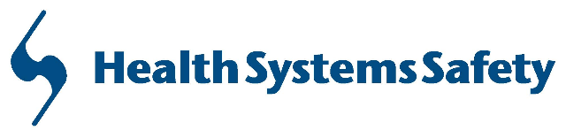

Occupational Safety, Industrial Hygiene, Emergency Management and training for the healthcare community. Instructors are healthcare professionals with clinical experience, hazardous materials expertise and internationally recognized certifications.

No cost for the first 150 persons – supported by funding from the National Institutes of Environmental Health and Safety Grant Number 2 U45 ES006179-19

These courses are specifically designed for healthcare (e.g. hospital emergency room, etc.) personnel who have been assigned to participate as a member of a patient decontamination team for victims who may be contaminated when they come in for medical assistance. They meet the minimum training required for both the initial and annual refreshers. The class teaches and practices the basics of Operations level (defensive) response from the healthcare viewpoint. Topics such as; hospital emergency control plans, patient decontamination, and the protective equipment available to them are included. Classes are a blend of lecture and hands-on practice donning and doffing PPE and DECON by the students.

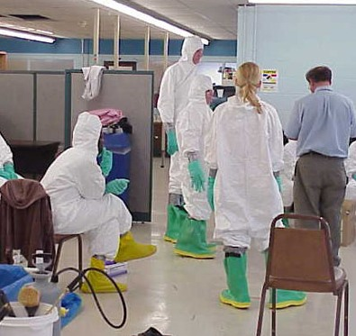
We also offer a 16 Hour Hands-on DECON course in this series.

4-HOUR REFRESHER HAZWOPER OPERATIONS FOR FIRST RECEIVERS

Classes at University at Buffalo,
Main Street Campus by arrangement

Or

Courses are also offered at client facilities for groups of 10 or more.

Pre-requisites: Trained to Operations level under 29CFR1910.120 (q) (6) (ii)

HAZWOPER First Responder, Operations Level for First Receivers

The 8-hour initial course and 4-hour refresher course meet the requirements of 29 CFR 1910.120 (q)(6)(ii) and (q)(8)(i) for initial and annual Refresher Operations Level Training and the intent of the OSHA Letter of Interpretation to cover the contents of the “OSHA Best Practices for First Receivers” document. Individuals in the Healthcare industry who may serve as First Receivers in the hospital facility and may respond to an incident should take the initial course and the annual refreshers. Participants will receive instruction in the defensive actions needed to protect themselves, nearby persons, property, and the environment. Further the course will provide information to the responder on the extent of their own actions, and their role in the response, so that they can maintain their own safety.

For more information,
to inquire about other
training, or
to register for courses

Contact Joe Syracuse at

SUNY Buffalo
Toxicology Research
Center

Phone: (716) 829-2125
Fax: (716) 829-2806
E-mail: jsyracus@buffalo.edu

Please make note of our web page address :

https://medicine.buffalo.edu/research/research_centers/trc.html

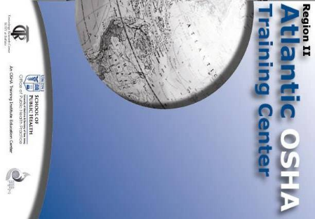
ATLANTIC OSHA TRAINING CENTER
UNIVERSITY AT BUFFALO
Cary Hall Room 15
3435 Main Street
Buffalo, New York 14214

HAZWOPER OPERATIONS
FOR
FIRST RECEIVERS
INITIAL & REFRESHER

