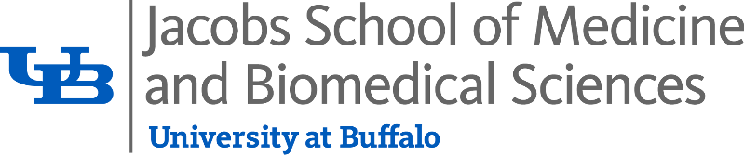

**Photo and Promotional Release Form**

I hereby consent to be interviewed, recorded, photographed, videotaped or filmed by representatives of the Jacobs School of Medicine and Biomedical Sciences at the University at Buffalo for purposes of publication, display or broadcast (print, web, digital display, social media, and all other forms of media).

I agree that such interviews, recordings, articles, quotes, photographs, films, audio or video and/or any reproductions of same in any form, are the property of the University at Buffalo, and I relinquish any present or future claim for reimbursement for said photographic or film reproduction of my likeness or for said testimonials by me.

I hereby release the University at Buffalo, its affiliates, employees, representatives and agents from any and all claims, demands, costs and liability that may arise from the use of these interviews, recordings, photographs, videotapes or films, and/or any reproductions of same in any form, as described above, arising out of being interviewed, recorded, photographed, videotaped or filmed.

I acknowledge that I have read this consent form in its entirety, or it has been read (or translated) to me, and I have had the opportunity to ask questions about it and understand it.

Date: ________________________________________________________________________ Name (print): _________________________________________________________________ Signature: _____________________________________________________________________

*Parent or Legal Guardian name and signature required for individuals under age 18